View this email in your browser
IMPORTANT MEETING ON APRIL 5th

If the Notice of Intent and associated Beach Management Plan is not approved, there will be NO PUBLIC OSV ACCESS ON CHAPPY.

To legally drive OSVs on the beaches in Massachusetts, the beach manager must file for a permit to do so with the local Conservation Commission and the State. The Trustees have not had an approved beach driving permit since 2016. TTOR needed to submit for a new application called an Notice of Intent (NOI) as well as filing an interim Beach Management Plan with the Edgartown Conservation Commission (Con Com) and other state agencies to allow OSV Access on Wasque, Lelands and a portion of the Cape Pogue Refuge for the 2023 season and beyond. This NOI also allows TTOR to sell OSV passes.

On the April 5th starting at 5:00PM the TTOR will be presenting, for the seventh (7th) time since November 2022, a revision of their plan which includes answers to questions that Con Com has requested.

If the NOI and associated Beach Management Plan is not approved, there will be NO PUBLIC OSV ACCESS ON CHAPPY.

Here is a link to the agenda of the meeting including a Zoom link and meeting material
Edgartown Conservation Website

Please attend, share your support and shared your voice.

To keep up to date with latest on beachgoers access, please join MV Beachgoers Access - https://www.facebook.com/groups/mvbeachgoeraccess
Peter Sliwkowski, President of MV Beachgoers Access Group
Make a Donation

MV Beachgoers Access is using PayPal to make to easy to donate
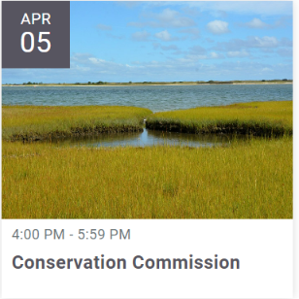
Copyright (C) 2023 MV Beachgoers Access Group. All rights reserved.
You are receiving this email because you opted in via our website.
Want to change how you receive these emails?
You can update your preferences or unsubscribe

