MVSA November Newsletter
November Meeting

Monthly meetings resumed on November 3rd with more than twenty members in attendance at the MV Rod & Gun Club. President Scarpone outlined future meetings which with the exception of February, will be held on the first Tuesday of every month. Scarpone outlined some upcoming meetings which will include Cooper Gilkes who will talk about the trawler by-catch of big stripers and the striper issue in general. Another meeting will feature Among the Flowers owner and former Striper Cup Angler of the Year winner Pat Toomey who will speak about the proper care and preparation of your catch and maybe share a few recipes and fishing tips.

The Prez also threw out some ideas for new club activities which include a revised Brown shark tournament as well as a tag sale of used fishing tackle which will be open to the public. We also hope to have Shellfish Warden Paul Bagnell address the club and the “Make-Your-Own” lure contest which will also be held again.

We talked about our annual awards luncheon and raffle and Kathi Pogoda passed out merchant solicitation assignments. The event will again be held on January 30, at the Old whaling Church in Edgartown. Kathi also encouraged members to donate an item or two themselves. This is our only fundraiser of the year and most of the money we raise gets recycled back to the community in the form of donations to causes like the Kids Trout Derby and annual high school scholarship.

Scarpone said he will be ordering more MVSA T-Shirts and will look into the cost of ordering club hoodies.

Finally, Don announced that Dave Kolb will fill in as the club Secretary at least until the elections in
January.

In House Derby

With the season rapidly drawing to a close, the leaders in our 2015 In-House Derby are:

Shore All Tackle

Striped Bass-Don Scarpone,35.57 lbs.

Bluefish- Jack Livingston, 15.46 lbs.

Bonito- Dave Nash, 5.98 lbs.

False Albacore- Kathi Pogoda, 10.10 lbs

Boat All Tackle

Bluefish-Jack Kimberly, 13.59 lbs.

False Albacore-Jim Cornwell, 9.54 lbs.

(There were no striped bass or bonito entries in this category)

Boat Flyrod

False Albacore-Ed Lepore, 9.54 lbs.

(There were no striped bass, bluefish or bonito entries on this category)

Pin Winners

September

Striped Bass- Ron Domurat, 18.82 lbs.
Bluefish-Cosmin Creanga, 13.62 lbs.
Bonito-Ron McKee, 5.64 lbs.
False Albacore-Kathi Pogda, 10.10 lbs.

October

Striped Bass- Janet Messineo, 21.02 lbs
Bluefish-Jack Livingston, 15.46 lbs.
Bonito-Dave Nash, 5.98 lbs.
False Albacore-Janet Messineo, 8.80 lbs

Fishing Report

When the Derby ended fishing just seemed to tank! Whether that was due to a late migration or simply a case of Derby burnout and lack of reports, the fishing went down the tubes in a hurry. The great false albacore fishing we were experiencing seemed to end with the Derby and catches of striped bass that were lacking during the Derby, got worse after. Even late season bluefish were almost non-existent and we haven’t heard of one post Derby bonito being caught.
However, over the last few days, there has been a glimmer of hope with some stripers reporting being caught along the south shore from the Wasque Rip to Gay Head. So if you can stand the frustration of coming up empty on most outings, there is still time to put a late season bend in your rod and perhaps even win a pin or the entire In-House-Derby. Historically, the biggest stripers of the year are caught late in the season.

Trustees Property Report for October
Chris Kennedy sent along this seasonal recap
Late in September we witnessed the reopening of the Norton Point Breach adjacent to Wasque Point. The opening lasted approximately three weeks but the connection is tentative at best. During recent high SE winds the “connector” was heavily over-washed and even on November 2 with a gentle S wind this portion of beach experienced periodic over-washing.

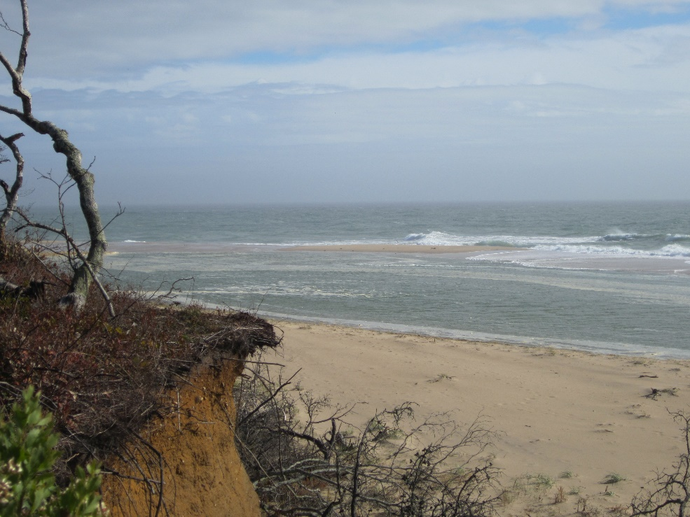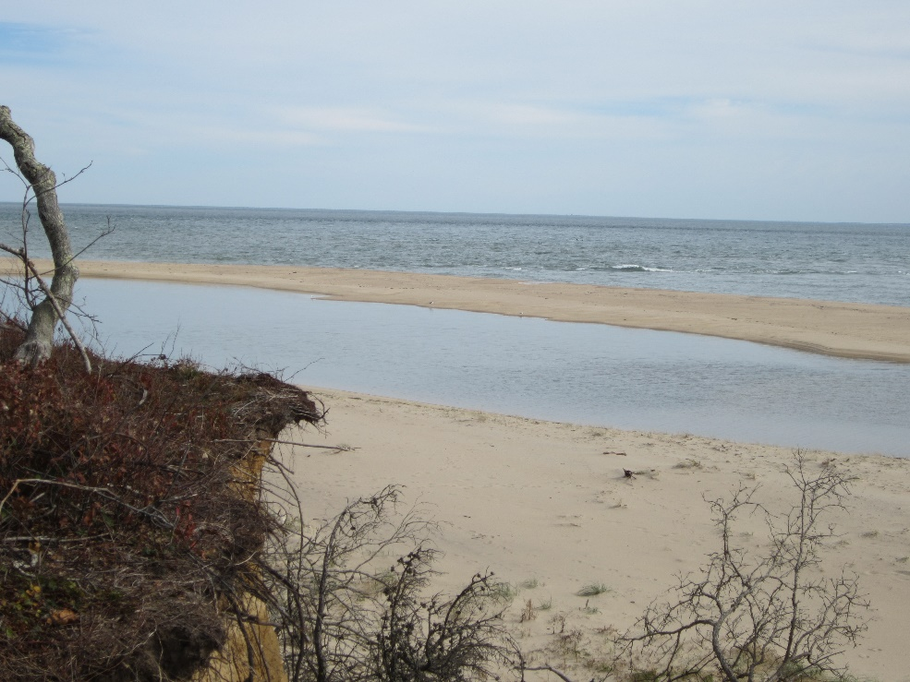
We are evaluating this section of the property daily and will re-open it for OSV access when we feel it is safe to do so.
(On Friday November 6, just a few days after he sent along this report, we received the following good news from Chris Kennedy.
Just a quick note to let you know that the beach connector between Norton Point Beach and Wasque has been reopened for OSV travel. It is still narrow and limited to a single track in width but as long as drivers yield to oncoming traffic and allow them to pass before entering the narrow section we shouldn't have any problems. Still some signs of fish around with birds working some pods off of the beach at Cape Poge.))
We re-opened the last remaining portion of East Beach, just south of the Jetties, which had been closed due to significant beach erosion since September. Even though this beach section has been reopened drivers should avoid this area whenever we expect to see high easterly winds this winter. All beaches are open for OSV access (except for Wasque Point).

Winter work will continue at Wasque, Norton Point and Cape Pogue. At Wasque, the crew has been mowing approximately 50 acres of grassland to encourage rare plant growth next season. The mowing also has a beneficial effect on the low bush blueberries which are numerous in these areas.
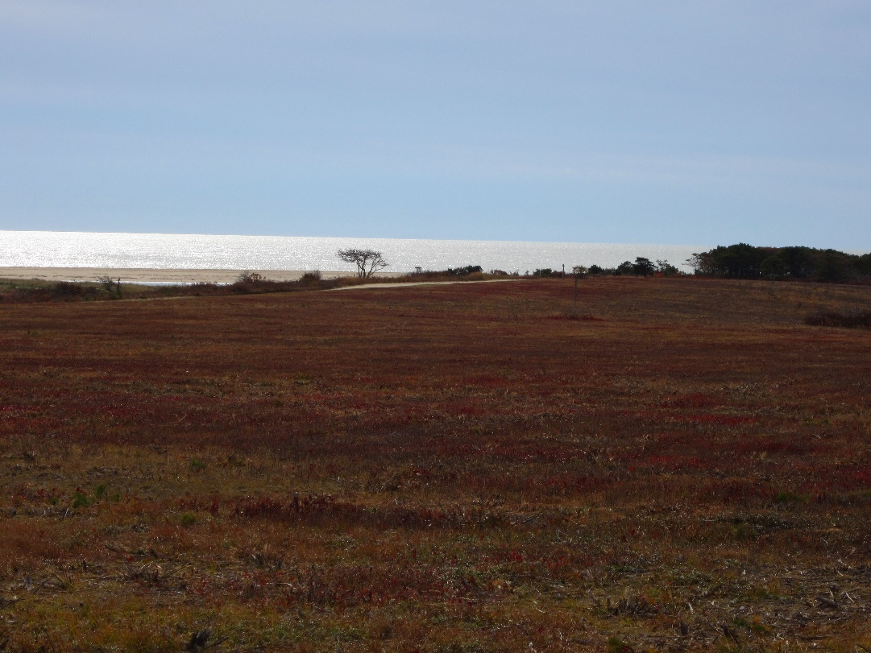
At Norton Point recent coastal storms have served to remind us that the beach is subject to periodic flooding of the inside trails with strong northerly winds at high tide. Enjoy the beach but keep an eye to the sky.
Finally, as we begin to look forward to the solitude of the beaches in winter, please help us by helping others you see on the beach. It is inevitable that the cold days of winter seem to draw the inexperienced drivers to the beaches on weekend afternoons. It’s funny but the inexperienced drivers always seem to wait to bury the family SUV right at half time of the Pats games. We can usually count on getting one or two calls from the Communications Center during the second half of the Patriots games. When we get out to the beach to investigate the call we usually find a bewildered looking father with three kids playing on the beach and a really unhappy looking wife who is telling her husband, “I told you not to drive on the beach!” As you can imagine, 99% of the time bewildered dad hasn’t let any air out of his tires. Help them out and you will feel better and you may even save a marriage or two at the same time!
Despite the season, we are still on duty. Any questions feel free to call Chris Kennedy at 508-627-7689 (office phone which rings at his house too), Chris Bruno our Assistant Superintendent for Chappy at 508-627-1380 (office phone which rings at his house) or Jack Klumick our Assistant Superintendent for Norton Point and Up-Island at 508-627-2619 (cell phone). We will also periodically update the beach access hotline at 508-627-8390 as conditions on the beach change. If you haven’t done so, check out our Facebook page at www.facebook.com/trusteesmv.
Have a great off-season and thank you all for your support over the past year.

“The Derby”

The Derby was plagued by strong winds and some bad weather and with the exception of false albacore, some generally bad fishing. But MVSA members once again excelled in the Martha’s Vineyard Striped Bass and Bluefish Derby-the annual grand celebration of Island fishing.
Led by Jack Livingston who finished second in the all tackle shore bluefish division and missed being a Grand Leader for the third time by the weight of a few peanut bunkers, one third of our members won a prize of some kind, including fifteen major awards, sixteen weekly prizes, two shore Hat Tricks (out of three awarded) and almost fifty daily pins. Our seniors did exceptionally well with Jim Cornwell winning the senior boat false albacore division, Janet Messineo the shore striped bass division and Jack Creighton the shore bluefish division. Also, ageless “Bonito” Ed Lepore placed second overall in the Fly-Rod Boat False Albacore division. In addition, Kathi Pogoda and Janet Messineo each took home $500 for catching the largest False Albacore and Striped Bass on Super Saturdays. Our junior members also did well with Victoria Scott and Jack A. O’Connell wining the boat and shore bluefish divisions. And notable is the fact that out of 220 shore bluefish weighed in, our members caught six of the ten largest fish!

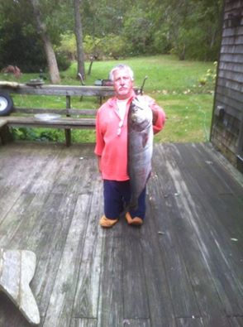 Photo by Sharlee (the Queen) Livingston

2015 MVSA Member Derby Accomplishments
Major Awards
Overall Division Leaders
All Tackle Shore Bluefish, 2nd, Jack Livingston
Flyrod Boat False Albacore, 2nd, Ed Lepore
Junior All Tackle Boat Bluefish, 1st, Victoria Scott
Junior All Tackle Shore Bluefish, 1st, Jack A. O’Connell
Senior Grand Leaders
Madison Alwardt Memorial Award, Shore Bluefish, Jack Creighton
Ray Metcalf Memorial Award, Shore Striped Bass, Janet Messineo
Howie Leonard Memorial Award, Boat False Albacore, Jim Cornwell
Special Awards
James P. Catlow Memorial Award, Largest Shore Bluefish caught by an Male Island Resident, Jack Livingston
George H. Pye Award for the heaviest shore bluefish caught by a non-resident senior, Jack Creighton
George H. Pye Award for the heaviest shore bluefish caught by a resident senior, Ron Domurat
Victor Danberg Trophy for the heaviest bluefish caught by a junior girl, Victoria Scott
Cutler Bike Shop Award, Jack A. Connell
Roberto Germani Catch & Release Award, False Albacore, Jack Livingston, Bluefish, Ed Lepore
SUP Writing Contest, Phoenix Russell

Super Saturday $500 Winner
Kathi Pogoda, False Albacore, Janet Messineo, Striped Bass
Hat Trick
Ron Domurat, Ralph Peckham (Bluefish)
Weekly Awards
Two, Janet Messineo, Ron Domurat, Ed Lepore
One, Kathi Pogoda, Jack Livingston, Jim Cornwell, Victoria Scott, Phoenix Russell, Jack A. O’Connell, Karen Kukolich, Versie Geary, Ron McKee, Lou Ferrucci
Daily Awards
Five, Jack Creighton, Ron Domurat
Four, Jack Livingston, Ralph Peckham, Creanga Cosmin
Three, Ed Amaral, Peter Sliwkowski, Jason Patterson
Two, Janet Messineo, Gary Fudem, Keith McArt, Mark Wrabel
One, David Cron, Dave Nash, Jim Cornwell, Victoria Scott, Phoenix Russell, Jack A. O’Connell, John P. O’Connell, Ed Wessel, Melissa Sliwkowski, Chantale Duguay, Don Scarpone, Versie Geary, Jason Graves, Steve Baccelli, Ron McKee, Sol Watson
Octoberfish
Two of our members also scored prizes in the 23rd Annual Octoberfish contest sponsored by Larry’s Tackle Shop. Ron Domurat was second in the shore bluefish division followed closely by Mark Wrabel in third.

MVSA Website
Web master Dave Balon reports that our website remains active. For the month of September, the site had 1100 visits including visits from 830 new viewers. There were 520 page views for Island Fishing Info, 204 for MVSA Club Info and 120 for the In-House-Derby as well as a multitude of other searches within the site. Dave said even during the Derby the site had been active. “I am sure they were looking for derby hot spots-ha!”
MVSA Calendar

December Meeting-December 1, MV Rod & Gun Club, 7:00 PM, Speaker Cooper Gilkes, Pizza

January Meeting-January 5, MV Rod & Gun Club, 7:00 PM, Pizza

Annual Awards Ceremony and Banquet-January 30, 2016, 1:00PM

March Meeting-March 1, MV Rod & Gun Club, 7:00 PM, Speaker TBA, Pizza

April Meeting-April 5, MV Rod & Gun Club, 7:00 PM, Speaker TBA, Pizza

