MVSA May 2015 Newsletter
May Meeting
At our May 5 meeting President Scarpone reported that the clubs bank balance stood at $9500 and we recently paid $1300 for liability insurance, $1000 for our annual MVRHS scholarship and donated $500 to the MV Rod & Gun Club for their annual Kid’s Trout Derby.
Scarpone also noted that this was our last indoor meeting until the fall. The next meeting will be held on East Beach on Saturday June 13 beginning at 4:00 PM and will include the “Make your own lure” contest. As announced previously, prizes will be awarded to the member(s) whose lure is the most unique, catches the most fish and/or the biggest fish. Hot dogs, chips and sodas will be available. This event promises to be a lot of fun so use your imagination and get busy.
The “prez” also noted that our membership stood at 141 and many members still have not paid their 2015 dues. The grace period has been extended until 5/31/2015. Any member still in arrears on that date will no longer be considered a member and removed from the mailing list.
Peter Johnson floated the idea of a “Fishing-Old and New” theme for the 2015 Agricultural Fair display and members were in agreement. Members willing to help with the design or provide items for the display can contact Peter at robertslures@earthlink.net or 508-696-8925.
The subject of our web-site was brought up and Don Scarpone mentioned how much work goes into maintaining the site and how much good information is on it. Web-Master Dave Balon said that for the month of April we had 730 visitors or more than 25 visits per day and more than 2400 viewed pages. We remain in the Top 3 Google searches about Vineyard Fishing.
We also discussed our MVSA Facebook page and whether non-members should continue to be added. Similar to our web-site, off-island anglers are hungry for fishing information about the Vineyard and the FB page is one way to obtain it. Members agreed that for now, non-members should continue to be added with the hope that some will eventually be convinced to join our club.
Paul Schultz was our speaker for the night and told us about years past and the number of fifty pound bass he and other members like Ed Jerome and Cooper Gilkes caught at the Gut and Wasque. Paul said he caught all of his 50’s on live eels and uses a 4/0 “J” hook and prefers 15”-16” eels. He says after the initial hit, he usually opens the bail and lets the fish run for a ten count before setting the hook.
A discussion of eel skin plugs and rigged eels also ensued. Many said they have used them successfully and there is nothing subtle about the hit on a “skin plug”. Skinning an eel is relatively simple and once a “skin plug” has been made it can be used multiple times by placing the lure in a plastic bag along with a layer of Kosher salt and stored in the freezer. Most of our local tackle shops can obtain large eel skins from Mako’s Bait & Tackle in Buzzards Bay.

Fishing Report
As of 5/10, a few schoolies up to keeper size have been caught at the pond openings and Menemsha but as far as we know no bluefish have been caught yet. The good news is that that the Cape is loaded with squid and points south of us are reporting outstanding fishing. Striped bass have invaded the area around the mouth of the Connecticut River and big bluefish up to 18 lbs. are being caught daily along Long Island beaches and the Jersey shore where fish are slaughtering schools of big bunker. We could be in for a banner spring season.
First Keeper Bass and First Bluefish
President Scarpone has put a bounty on the head of the first keeper bass and the first bluefish caught by an MVSA member. Don will award a Striper Maniac lure to the first club member to forward a picture of either a keeper bass or bluefish to him at donaldscarpone@yahoo.com or posts a photo to the MVSA FB page.
Beach Report
As of May 3, OSV drivers with both permits have been able to drive onto the beach on Norton Point and continue to Wasque Point and beyond all the way to the Gut. The beaches are currently in good shape but more terns are arriving daily and pairs of piping plovers have been reported on East Beach and the area around the jetties, so closures are imminent. The area around Wasque Point continues to build and stabilize and two nice Rips have developed which should provide some good fishing in the very near future.
Riparian Rights
At the last MVSA monthly meeting, we had a lively discussion about Riparian Rights or the rights of surfcasters to fish on private property. The bottom line in Massachusetts is this; as an angler, you have the right to be fishing on private property, at, or even above the high tide line. Where it becomes tricky is how you access the property. If you do not have permission from the owner to access the property by vehicle, you must walk or boat there. Once there, the property owner is bound by state law to allow you to stay there. But as indicated in the last two paragraphs below, over the years, the interpretation of the law has led to many disputes between property owners and fisherman. Those in attendance at our meeting agreed that when confronted in this situation, the best advice is to handle it with diplomacy, courtesy and respect. If handled correctly, the confrontation could lead to permanent vehicle access.

Dave Nash sent along the following information from the Massachusetts Real Estate Law Blog.

“Massachusetts has a unique set of laws giving coastal property owners more extensive private rights to beachfront area than other states. In most coastal states, there is unlimited public access to beachfront areas and you can walk unfettered along the beach. In Massachusetts, however, that is not the case. Here private coastal property owners own the beach area adjacent to their properties down to the mean low tide area, with some limited public access exceptions. This is how the concept of “private” beach areas have been established.

The origin of this law dates back to the Mayflower days. In order to facilitate coastal development, under the Colonial Ordinances of 1641-47, the Massachusetts Bay Colony conveyed most, but not all, rights of ownership to the area between the average or mean high water mark and the low water mark (up to 100 “rods,” or 1,650 feet, from the high water mark) to all private coastal landowners. The land—but not the water—between the two tide marks is known as “private tidelands.” This typically includes all of the wet sand area on beaches.

The general rule is that with some limited exceptions explained below, beach-goers in Massachusetts cannot access any private beach area down to the low tide water mark without the permission of the beachfront property owner.

Limited Public Beach Access Between Low and High Tide Area for “Fishing, Fowling and Navigation”

The Colonial Ordinance reserved three specific and important rights of public use within the private tidelands for “fishing, fowling and navigation.” Those permissible uses have been broadly interpreted by Massachusetts courts to include: (1) the right to fish or to collect shellfish on foot or from a vessel; (2) the right to navigate, including the right to float on a raft, windsurf, or sail; and (3) the right to hunt birds for sport or sustenance, on a boat or on foot. (Though there is no court decision on point, the Attorney General maintains that this right also covers bird-watching.)

Accordingly, the public has access to any so-called “private” beach or any private tideland area as long as you are legitimately engaging in “fishing, fowling, or navigation.”

These antiquated Massachusetts beach access laws have created many disputes between public beach-goers and wealthy coastal property owners who have attempted to enforce a “private beach” regime.

Under the Colonial Ordinance, no private property owner may deny access to someone who is fishing or hunting for birds.”

8th Annual Island Cup

Victor Colantonio forwarded the following information about this great inter-island fishing competition.

I hope the news of our 8th Island Cup Contest piques your interest and you’ll join in.

MVSA has Critical Need for Women Anglers
June 2015 marks the 8th Annual Island Cup Contest, America’s ONLY Team Surfcasting Competition (Men & Women). This year, MVSA’s team has a critical shortage of women anglers! Nantucket will have three women fishing this year and we want to match them up with our gals. Call me if you are considering participating this year; I’ll tell you all about NAC’s “Happy Hookers”.

We do our Best
We try to arrange our host/visitor match-ups to put together like-minded anglers with similar fishing styles. For example, last year a 60 year old dentist from New Jersey fished the Island Cup with NAC for the first time; we worked very hard to match him to a Vineyard angler with some nice teeth.

If you wonder what our contest is like call me or Jim & Jon Cornwell, Jim Fraser, Hawkeye Jacobs, Pete Sliwkowski, Joel Graves, Jay Graves, Matt Malowski, John Piekos, Steve Tirrell, Jim Mullen, Bob Lane, Michael Stimola or Ed Wessel.

Back to the Old Rules (No More Mr. Nice Guy)
Because Nantucket won in 2014 and they are leading the series 4-3, we are ending the three rules installed after our 2013 rout. Specifically, “The Graves Boys" will no longer need to fish only with night crawlers and bobbers; Jim Fraser need not spot George Williams one Bass weighing 10% of the Fish Kitty’s dollar value; and, Hawkeye can resume fishing standing up.

JUNE 19, 20, 21, 2015 on Nantucket
8th Annual Island Cup Contest on Nantucket
America’s ONLY Team Surfcasting Competition (Men & Women)

Defending Champion & Home Team: Nantucket Angler’s Club

Vs
Visiting Team: Martha’s Vineyard Surfcaster Association

Schedule: Friday, June 19 depart Hy-Line OB 1:25pm, arrive Nantucket 2:35 ($36). Sunday, June 21 depart Nantucket HyLine 2:50pm, arrive OB 4:00 ($36).
Contest Hours: Lines In 5:00pm Friday; Lines Out Noon Sunday. Tally sheets to NAC by 1:00pm Sunday; Cup presentation 2:00pm.
Contest: Artificial bait only, each angler’s heaviest Bluefish and Striper (28" min.) landed and verified by an opposing angler counts toward total team weight. Heaviest total team weight wins the Cup.
Accommodations: Host anglers provide visitors lodging, transportation and guiding. Cost for personal items, food and beverages are your own.
Fish Kitty: $20 per angler to “Fish Kitty” for the heaviest fish.
Tradition: Spirited competition in the surf gives way to neighborly behavior and a big dose of friendship when waters are still. Nantucket is up in the series 4 to 3.
Budgetary Cost for weekend: $200 (Hy-Line $72; Kitty $20; 5 meals @ $20).
Contact: Victor Colantonio at v.colantonio@gmail.com text / voice 617-413-6140.

Traveling MVSA Anglers

A few of our members traveled south for some fishing and sent along the following photos. In the first picture that’s Bob Beal on the right with a big Key West Mahi and Hawkeye with a 41” Jack Cravelle estimated to weigh 38 lbs.

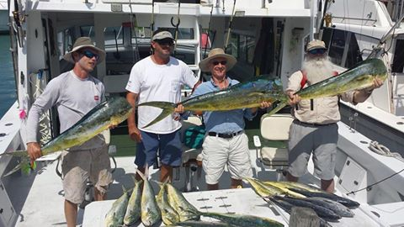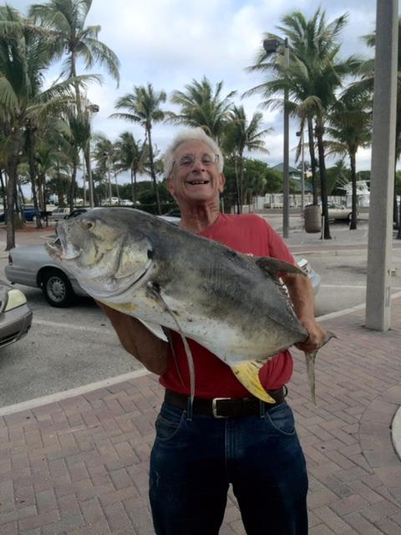

Barbara Rogers caught a 38” Permit estimated to weigh 35 lbs. also at Key West, and President Don Scarpone pictured with a nice Redfish he caught during a recent trip to Savannah GA and Charleston SC.

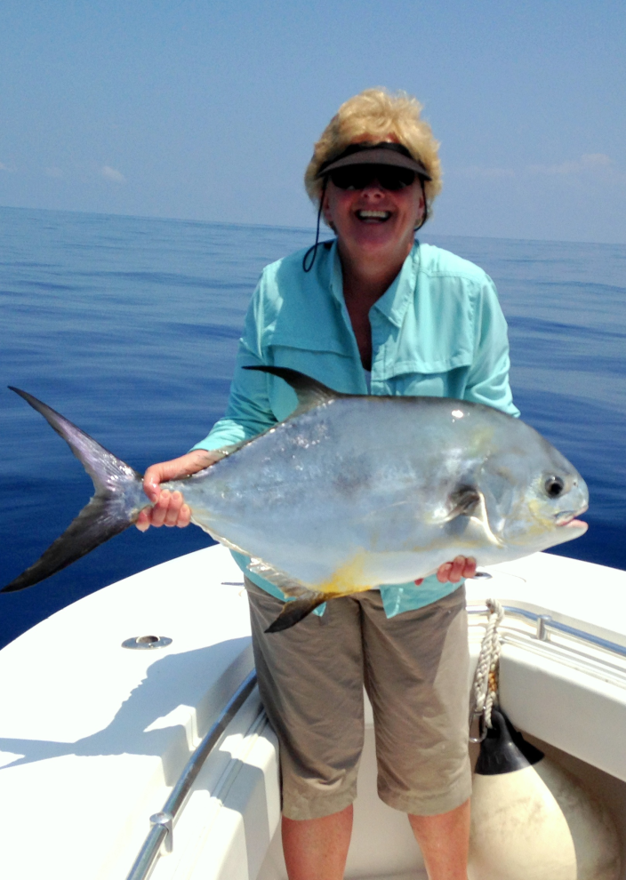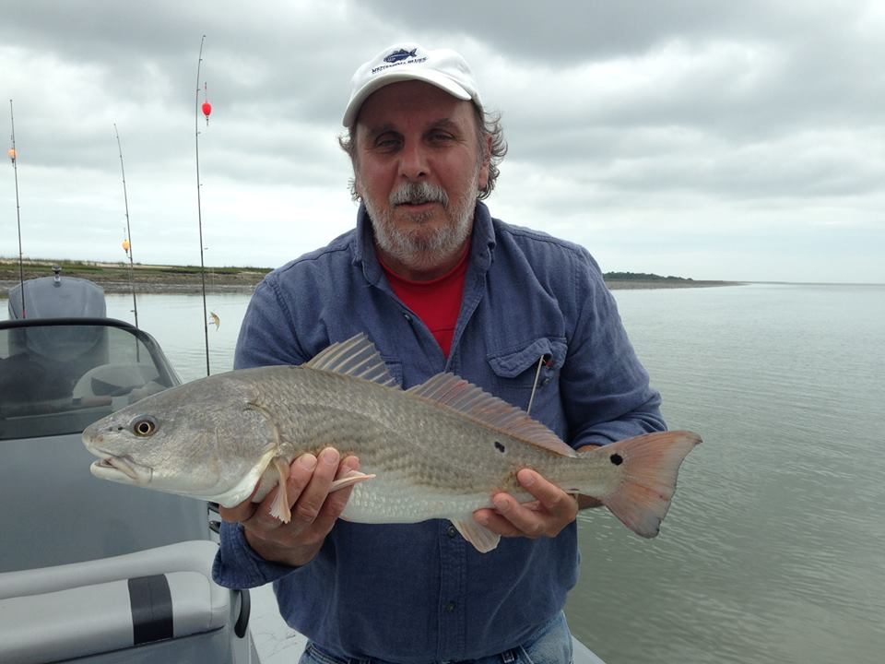

Stripers Forever Release a Breeder Club

At our last meeting, Ron Domurat gave a brief update on the activities of Stripers Forever (SF) a non-profit, all volunteer, internet-based advocacy organization that seeks game fish status for striped bass on the Atlantic Coast. Game fish status would effectively eliminate commercial fishing for stripers. There is no charge to become a member but SF relies upon private donations and sponsors to support its advocacy efforts. A fun way for MVSA members to join this group of hardworking and dedicated sportsman is to “Release a Breeder” (RBC).

This is largely an honor system, though either a photograph of the fish or the name of a witness is required with the application. The minimum size for membership in the RBC is 36” total length. If a picture is supplied with the application we will publish it next to the name of the club member. The fish must be released alive and either left in the water or held out only very briefly for the picture. These are the only rules.

Rewards
For the 2015 season we are proud to announce our partnership with Cheeky Fly Fishing. As a sponsor of the 2015 RBC Cheeky has donated an amazing prize package, not just for a select few members but also for every member who joins the club. Here is how it works. Every angler who becomes a member of the club by releasing a 36” total length or larger striper will receive a $15 Cheeky Bucks gift certificate and some Cheeky stickers and swag along with the RBC decal and custom signed/dated certificate.
Three anglers will be drawn randomly from all fish entered. The more fish you enter, the more your chances. Prizes from Cheeky are:
MOJO 425
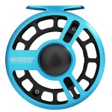
BOOST 400
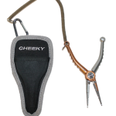

550 PLIERS
All members will receive the following:
$15 CHEEKY BUCKS
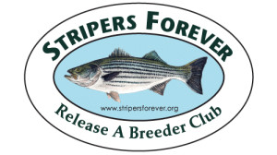
RBC DECAL

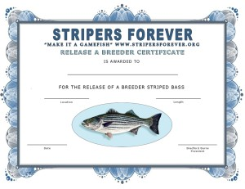

Release A Breeder: Angler Application
- Angler Members
- Angler Application
By submitting this application I agree to endorse the conservation and game fish goals of Stripers Forever and agree to be entered into our membership database. No signature is required, just fill out and submit the following application. All applications are free and we will list all qualifying fish submitted on the angler and guide/captain pages. A decal and certificate will be sent to the angler for the first fish submitted for the calendar year. For any angler wishing to receive additional decals and certificates a $10 contribution is required using pay pal on our donate page for each additional fish submitted. Thank you for your support.
Top of Form
- Angler Name*
- Location of Catch*
- Length of Fish*
- Date of Release*
- Upload Image of Fish

- Name of Submitter*
First Last
- Address of Submitter*
Street Address Address Line 2 City State / Province / Region ZIP / Postal Code
- Email of Submitter*
- This is my first application for this calendar year.
  - Please check if answer is yes.
- Name of Guide/Captain (if applicable)
- Witness to Catch and Release (if applicable, required without image)
- Are you a guide/captain submitting this application for a client.
  - Please check if answer is yes.
Bottom of Form

Results of Stripers Forever Annual Member Survey

In 2014 we received 830 responses to our annual survey. 752, or 84% of the respondents, have fished for stripers for more than 10 years. This is a very experienced sample of the angling population, many of them fished for stripers throughout the good years of the 1990s and early 2000s then the subsequent decline. This year’s survey has again produced a good representative sampling of sentiments from fishers all along the striper’s migratory range, and as usual MA and NJ vied for the greatest contributions with 206 and 199 completed surveys respectively.

2014 was another year of declining sentiment. 88% of fishers reported catching fewer fish compared to just 2% reporting catching more. Also, 71% said they were catching smaller fish compared to only 15% claiming they were larger. It seems evident that most of the older, larger fish from the great year classes of the 1990s and early 2000s have been removed from the population leaving us with smaller fish and many less fish from the poor year classes that have generally characterized the fishery since 2003.

The survey shows that our members continue to believe we should not be harvesting large, breeding stripers, that they want to set aside a high percentage of the current commercial catch for conservation – and not harvest it themselves – and that they are willing to buy a stamp to finance the buyout of the commercial fishery.

We had survey results from 77 guides, which is down from 89 last year. Without a doubt the decline in striper fishing is hurting this valuable industry as well as the related fishing tourism and tackle businesses. The guides know how to fish their areas, though, and can usually produce the best results possible from their home waters. If you are thinking about a guided trip please check out the guides and tackle shops listed on the Stripers Forever website.

We will send this information to the press and to fishery policy makers everywhere. We hope that you will use this information personally to help us advocate for the goal of coast-wide striped bass game fish.

Additional information about Stripers Forever can be obtained by visiting their web-site at: www.stripersforeer.org

MVSA Calendar

June Meeting, Saturday June 13, 4:00 PM, East Beach. Make Your Own Lure Contest, Picnic
donaldscarpone@yahoo.com, 508-627-1269

Island Cup Fishing Challenge-Nantucket. June 19 –June 21. Victor Colantonio,
617-413-6140. v.colantonio@gmail.com

Annual Summer Picnic, 4:00 PM, July 11, 2015, Bend in the Road Beach.
donaldscarpone@yahoo.com, 508-627-1269

August Meeting-Saturday August 8, 2015 5:00-10:00 PM, East Beach. Food, Fishing Contest
donaldscarpone@yahoo.com, 508-627-1269

70th Annual MV Striped Bass & Bluefish Derby, 12:01 AM, Sept. 13, 2015 thru 10:00 PM, October 17, 2015.

