MVSA March 2015 Newsletter

March Meeting
President Scarpone opened the March meeting by introducing and welcoming new members, Herb Foster, Joe Rogers and Phoenix Russell, then gave a financial update on the raffle and silent auction proceeds from our Annual Awards Ceremony.. Don said we made a total of $6005 which was slightly better than the 2014 event and excellent considering the inclement weather and smaller turnout. Thanks again to all who attended, donated merchandise and volunteered to help.
Tackle Sale and Swap-President Scarpone also re-capped some upcoming activities including the Tackle Sale and Swap to be held at the April meeting as well as the April 11th beach clean-up.
Build Your Own Lure Contest-Another event to look forward to is the “Build your Own” lure contest which will be held on Saturday June 13 on East Beach in front of Dike Bridge. The “Prez” showed a couple of lures that he recently made out of a simple kitchen knife and spoon and repeated that just about anything goes with the exception of a modified store bought lure. Prizes will be given for the most fish caught, the biggest and a special prize for the most original design. This event should be a lot of fun and promises to grow in the years to come so put your imagination to work and get busy making your lure(s).
Future Meetings-Don also stated that beginning with the June meeting, the club will continue to meet throughout the summer on the second Saturday of each month and with the exception of the annual summer picnic, which will be held at Bend in the Road Beach, the meetings will be held on East Beach. As with last year, a fishing contest will be held at all summer meetings.
In-House Derby- With regard to the MVSA In-House Derby, Peter Johnson passed around a sample of a beautifully done ceramic striped bass that he suggested could be used as a “Top Fish” award instead of the plaques the club have been giving away for years. A vote was taken and those present unanimously agreed to replace the plaques with the fish.
Janet Messineo-Bob Lane brought everyone’s attention to the fact that a terrific Mike Laptew picture of own Janet Messineo leaning into a cast, graces the cover of this year’s MA DMF Fisheries Rules Brochure. The photo is also on the MA DMF web-site.
Book Library- Our library is still expanding and includes some new offerings as well as some new DVR. Members are encouraged to take however many books are videos they like but please be sure to return them at a future meeting.

Making Plastic Lures-At the March meeting, member Jim Fraser gave an outstanding presentation on making lures with hard plastic and sent everyone in attendance home with a lure. For those of you who couldn’t make it, Jim sent along the following summary,
At the most recent MVSA meeting I gave a presentation of making lures with hard plastic. For those of you who could not attend, the talk was centered on the process and what could be done and why I got into it a number of years ago. For those of you who did attend you saw the method(s) I use and all of you took home a nice surfcasting plug made from the process. I realize plug making does not appeal to everyone but for the surfcaster who likes to tinker with his gear you might have some of your own ideas you would like to experiment with.
The process in a nutshell is:
- Come up with a master that you want to replicate. (make sure it is as perfect as it can be because every blemish will be replicated) This could be any plug you want to copy, one you have in your tackle bag, one you bought, or one you turned on a lathe.

- Make the Silicone mold. (use the products from www.aluminite.com web site. ( I suggest HS III silicon for one piece molds) (Also check out Larry Dalbergs site: www.makelure.com

- Reproduce the lure …Use the Amazing resin to make the hard plastic copies with the color and density (weight) of your choice. (write down your process for each lure)

- Test the lure (return to step 3 if you don’t like the performance using different density until you are happy) you should be able to make about 100+ plugs from your mold.
I posted the video portion of the talk on the MVSA Facebook page. You might want to view that to see it.
Visit NJtackle.com and capecodtackle.com (M&D’s in Wareham) for plug hardware (wires, grommets, etc)
Endless colors and options… possible additives include glow in the dark, florescent, porcelain powders, various metal powders (for either added weight and various finish effects), foam (for added or focused buoyancy ) One thing I did not mention at the meeting was if you make a lipped swimming plug or your design requires an embedded weight(s) or foam blocks you can do this easily by hot gluing the weight onto the thru-rod, after you pour the plastic and remove the rod the weights will remain firmly embedded. …the possibilities are endless.
Below are a few of the plugs I have made with the system over the last 10 or so years.

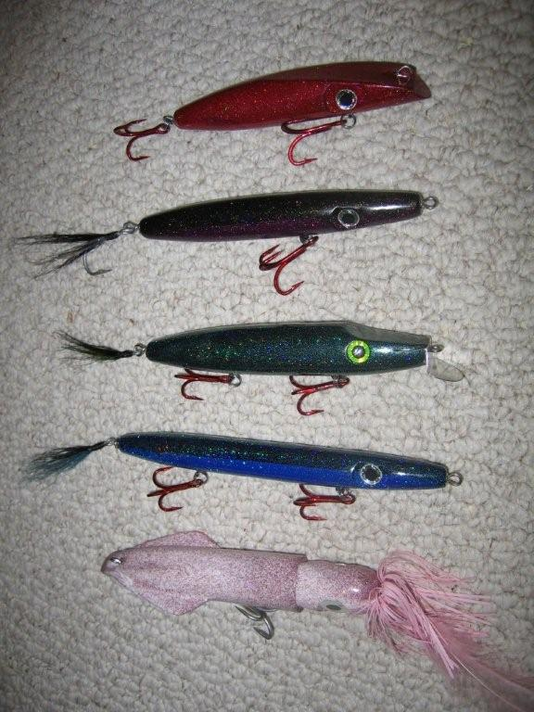
Beach Report-Chris Kennedy provided the following beach report.
Spring is finally here! The snow on the trails and beaches has finally melted, we've removed the roots and tree trunks which blocked many of the outside beach trails and have been preparing to get the shorebird fencing up on the beaches as mandated by state and federal shorebird laws. We've been hampered in places by the frozen beach which is just now giving up its grip (ever try pounding in 500 fence posts into ice).

Shorebirds are beginning to return slowly. We have reports of Oystercatchers, plovers, Osprey and Northern Harriers and yes, even a Snowy owl lingering at the Elbow and Norton Point.

As reported at the Surfcaster's Banquet OSV permit prices will remain the same this year. We're awaiting delivery of this year's OSV permits within the next week and we will begin selling permits from the Vineyard Haven office, Dukes County office and Coop's soon. I will let Ron Domurat know as soon as the permits come in. We are also looking at modifying some of the property rules for dogs and alcohol use for the coming summer. We will have more information shortly and will pass the information along as I receive it.

We closed the Dike Bridge swimming beach this morning (regularly closed to vehicle access from April 1 to Labor Day) and we're pleased to report that the Breach is quickly closing. As of 3/31, it was down to 15 feet wide at low tide. Won't be long now.

All other beaches and trails are open but I want to remind all that driving on the outside beach next to the Windmill House at the Elbow is prohibited--please use the Cape Poge Bay trails to access the Gut. We will again be asking kite boarders to stay 100 yards away from posted shorebird nesting areas and will be vigorously enforcing the no boat landing rules at the Gut during shorebird closures. For the first time in many years we will have a ranger stationed at the Gut during July and August to enforce the rules and keep boaters and kite boarders from landing in the plover nesting areas. This ranger will also be assessing boat landing fees at the Gut in non-shorebird areas ($20/boat/day or proof of TTOR membership). As well, one of our summer rangers, Tony Lima, will continue his study on compliance with tire pressure regulations at the Dike Bridge. Last season he found the average tire pressure to be slightly over 16 pounds (15 PSI is the max allowed). Overall, that's pretty good compliance when you realize that some drivers were found with 30 pounds of air in their tires--they normally didn't get too far!

It won't be long before the fish are in and Chris Bruno, our seasonal staff and I look forward to seeing our old friends for another season.

Breaking News-Less than 24 hours after Chris Kennedy provided us with a beach report, the breach closed (at least temporarily). As of 4:00 PM April 2nd, the Trustees have wisely roped off access to Leland’s Point. Please observe the rope line to avoid making tire ruts in the sand which could slow the rate of beach growth.
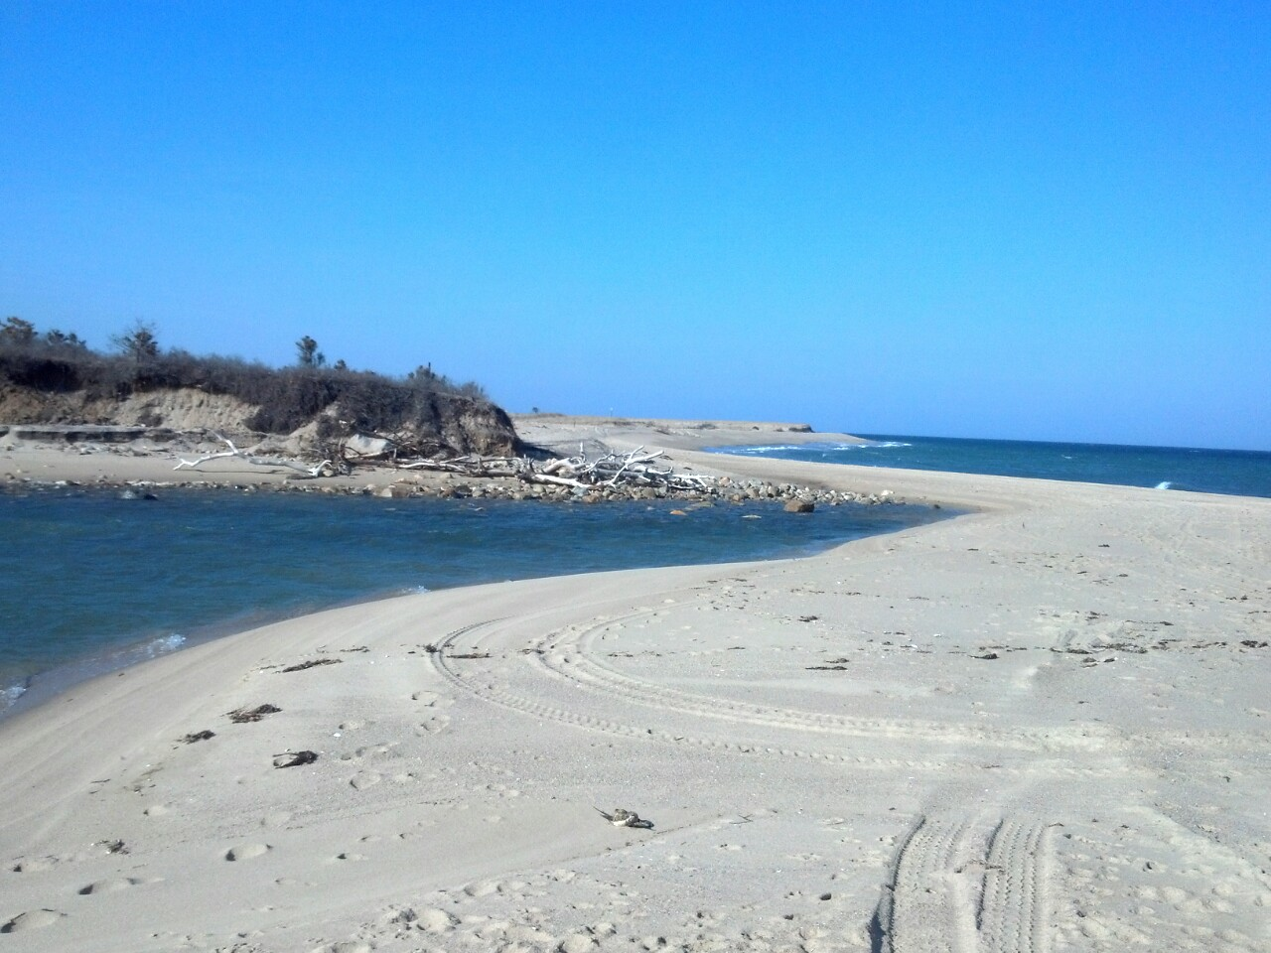

Massachusetts Salt Water Fishing Permits-MA Saltwater Fishing Permits are available and can be purchased from the MA DF web-site www.mass.gov/eea/agencies/dfg/dmf or by phone at 1-866-703-1925. State law requires that all anglers over the age of 16 must purchase a permit. The permit fee is $10 but is free to anglers 60 and over (a small processing fee may apply).
Striped Bass-To comply with the Atlantic States Marine Fisheries Commission mandate to reduce the recreational take of striped bass by 25%, Massachusetts has set new regualtions for the upcominmg season. In 2015, recreational anglers will be allowed to retain one fish which must be at least 28” in length. Massachusetts joins neighboring states including Rhode Island and Connecticut in adopting the new regualtion.

Summer picnic-The annual MVSA summer picnic and get together will be held on July 11 at Bend in the Road Beach beginning at 4:00 PM. Food and beverages will be provided by the club but desserts and salads are always welcome.
VCS Beach Clean-Up-Just a reminder about the MV Conservation Society Annual Beach Clean-up that will be held on April 11. As in the past, members will meet in the parking lot at the left fork at 10:00 AM. Trash bags will be provided but participants are advised to bring their own gloves. Immediately following the clean-up there will be an after-party at Harbor View Hotel featuring a light lunch (for as long as it lasts).
Island Cup Fishing Challenge-Also a reminder about the 2015 Island Cup Fishing The Nantucket Anglers Club which will be held on Nantucket the weekend of June 19-June 21.In addition to our regular MVSA participants, the club is looking for three women to match-up against the Nantucket women. Questions or sign-ups can be forwarded to Victor Colantonio, v.colantonio@gmail.com,
Winner of MVSA Science Fair Award for 2015 is Rose Engler, by Dave Nash and Dave Kolb
For some years now, the Surfcasters have sponsored an award at the Martha’s Vineyard Regional High School Science Fair. Our award is given on the basis of a project which has demonstrated a project that focuses on increasing the awareness and understanding of aspects of our marine environment. This year it was also awarded in memory of Donald K. Boyd. The recipient for 2015 is Rose Engler for her project titled;”Determining Impact of Shellfish Decomposition On pH levels in Brackish Water.”
Dave Kolb and Dave Nash served as judges in the fair this year and although they did not judge the MVSA award winner, Dave Kolb spoke with the winner after the judging. Ms Engler’s project consisted of a very well thought out experiment, carefully measuring and collecting data, and clearly and concisely presenting the results. With the hope of using readily available natural resources to potentially mitigate adverse environmental impact (acid rain), she took shells of different regional shellfish, ground them up, and measured their differential ability to change the pH (acidity) of different solutions. When her results were other than anticipated she, like any good scientist, analyzed the results and proposed alternative explanations. Most impressively, she hopes to continue her research in subsequent years and eventually bring the results to practical application. The MVSA is pleased and proud to present Ms. Engler our 2015 Science Fair Award. She was also an award winner in the investigative projects category.
Calendar

April Meeting, 7:00 PM, Tuesday, April 7, MV Rod & Gun Club. Used Tackle Swap & Sale, Pizza
donaldscarpone@yahoo.com, 508-627-1269

Vineyard Conservation Society Annual Beach Clean-Up, 10:00 11:00 AM, Saturday April 11, 2015, Left Fork, South Beach. Dave Nash, 508-627-4987, oystercatcher@verizon.net

May Meeting, 7:00 PM, Tuesday May 5, MV Rod & Gun Club, Pizza.
donaldscarpone@yahoo.com, 508-627-1269

June Meeting, Tuesday June 13, 5:00 PM, East Beach. Make Your Own Lure Contest, Picnic
donaldscarpone@yahoo.com, 508-627-1269

Island Cup Fishing Challenge-Nantucket. June 19 –June 21. Victor Colantonio, v.colantonio@gmail.com,

Summer Picnic, 4:00 PM, July 11, 2015, Bend in the Road Beach.
donaldscarpone@yahoo.com, 508-627-1269

70th Annual MV Striped Bass & Bluefish Derby, 12:01 AM, Sept. 13, 2015 thru 10:00 PM, October 17, 2015.

