June 2015 MVSA Newsletter
First Fish of the Year
Congratulations to members Jim Mullen and Mike Carotta for catching the first “keeper” bass and the first bluefish of the year. Mike submitted his membership application less than an hour before he caught his fish but has been travelling from Nebraska to the Vineyard for more than thirty years to take advantage of the spring bluefishing. Jim and Mike won custom made Ron McKee “Striper Maniac” lures for their efforts.

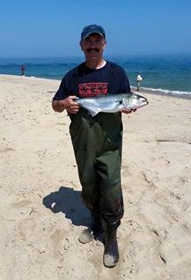

MVSA Members Score in Dick’s Bait & Tackle Tournament

MVSA members Jim Cornwell and Bob (Hawkeye) Jacobs represented our club nicely in the annual Memorial Day Tournament sponsored by Dick’s Bait & tackle. Jim won the shore bluefish division with a 9.90 lb. fish and in addition to a cash prize, Jim won a beautiful bluefish print donated by Abe (LureFish) Pieciak. Hawkeye placed second in the shore striped bass division with an 18.36 lb. fish. Well done guys!

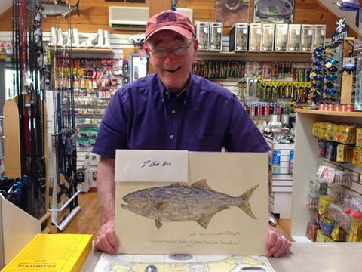

MVSA Scholarship Dave Nash
The 2015 scholarship presentations were made at MV Regional High School on June 12. The local newspapers carry a full list of the scholarship recipients and the number of scholarships as well as the dollar amount is truly staggering for an island with such a small population. The MVSA should be proud of it’s’ participation in this incredibly worthwhile effort thanks to the involvement of our members and the many merchants and individuals who contribute to our annual fundraising effort. The MVSA award this year was made to Charles Morano who will pursue a career in marine biology and has tentatively selected Connecticut College. Our award, as in past years, was presented on behalf of the MVSA by Mr. Ed Jerome.

MVSA Brings Back the Cup
Victor Colantonio

While the world darkens with news of ISI's momentum, diminished Mid-East peace-making, Russian expansion, Greece's debt crisis and slaughter in our places of worship, twelve men and women stepped out of the ground-swell of media negativism to board the 1:25pm Hy-Line Ferry to Nantucket last Friday. Twelve men and women, anglers all, stepped out chore-filled, work-a-day-lives to pursue the most optimistic of all human endeavors … to go fishing. Fishing is the best activity to combat the worldly blues should be bottled and freely poured over the well of human misery.
What other activity holds hope that a 100th cast will have a different outcome than the 99th; or the 500th will land fish after 499 failed to do so? It defies logic that anglers can think that the next, and the next, and the next try will result in success when dozens of their like-minded brethren form picket-fence on beaches, reeling in lines with empty hooks, hour after hour. The twelve anglers on Friday's Hy-Line and their counterparts on Nantucket might well hold a key to a practical definition of optimism ... a word that so well sets out the spirit of the catch & release team fishing competition between Martha's Vineyard Surfcasters Association and the Nantucket Anglers' Club.
The good news is that MV won the competition and evened the series at four all. There were lots of fish caught if one happened to be in the right place on the right tide. The margin of MV's victory was a whooping 1 pound 11 ounces, attributed to a catch by Team Sage, Jim Cornwell who landed a bluefish with just 15 minutes left in the 40 hour contest.
Held on Nantucket, June 19, 20 and 21, the shore bass prize was won by Colantonio at just 12 pounds this year and the largest bluefish was landed by Jason Graves at 10.2 pounds. Tre Wullschleger had the total weight at 18 pounds, 6 ounces.
The back story to the 2015 tournament was the weather, both forecasted and actual. Predictions were so dire that Nantucket postponed their Iron Man Competition for Sunday which had attracted a world class field to the island. They also cancelled the Island Run, a grueling slog "round the island over its beaches including a swim through well-known shark-infested waters. As expected, early Sunday morning, a violent front moved through delivering torrential rain, wind gusts in the 30s, thunder and very dangerous bolt-lightening. All Island Cup competitors wisely packed up their gear and headed off the cold beaches for hot showers. At about 11:45 am, 15 minutes before the "Line-Out Horn" blew, the storm subsided and the sky brightened as did Jim Cornwell's hope to end his 40-hour skunking to that point. Jim's Nantucket host Peter Krogh relented and afforded Cornwell just a few more casts, then, finally, "Just one more, Jim", probably his 5,501st of the weekend. BANG!!! Jim hooked and landed s small bluefish. Not normally worth weighing, it would erase Jim's "0 Lbs, 0 ozs" from the tally sheet to post "2 Lbs 1.6 Oz" registered from Krogh's digital scale. And with that, Jim Cornwell of Edgartown provided a fitting moral to this fishing report; the classic lesson of what happens when optimism and perseverance collide. You see, the total weights of the 2015 contest are: MVSA 64 pounds 7 ounces; Nantucket 62 pounds 12 ounces, just a 1 pound 11 ounces margin - one measly little last-minute bluefish, caught after everyone else had quit … made all the difference.
The MVSA team returned The Island Cup to MV on the Sunday Inter-Island Ferry; parading it through the streets of Oak Bluffs was cancelled due to forecasted inclement weather.
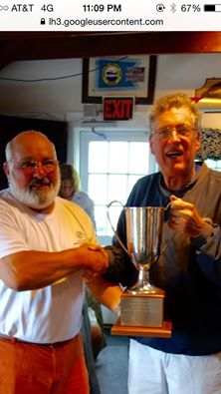

Nantucket team captain Scott Whitlock hands over the “Cup” to Vineyard captain Victor Colantonio (photo courtesy of Joel Graves)

Make Your Own Lure Contest

On Saturday June 13, more than twenty five members participated in the Make Your Own Lure Contest that was held at Wasque Point. Using their imagination and ingenuity as only fishermen can do, members submitted more than 30 entries and the only rule was that the lure could not be made by modifying an existing commercially produced lure. Prizes were given to the members whose lures were the most original and caught the most fish biggest fish. The event also featured a cookout.
An impartial jury of Lena Johnson, Robin Nash, Joyce Cornwell and Barbara Rogers judged Phil Horton’s "Dog Bone" and Ralph Peck ham’s PBR Special" as the winners of the most original lure award. But other more elaborate designs were crafted from broom handles, kitchen spoons, knives, stainless steel tubing, wooden dowels, hard rubber toys, wooden kitchen spoons, nut cracker handles and Azeks faux wood. Dave Kolb fashioned his by gluing a dolls head onto a 2 oz. jig. In addition, a cooking accident resulted in a discarded hot dog that was quickly rigged with a screw eye and submitted by our president. Unfortunately the hot bluefishing of the previous few days did not materialize and although everyone worked hard to prove their designs would work, no one caught a fish.

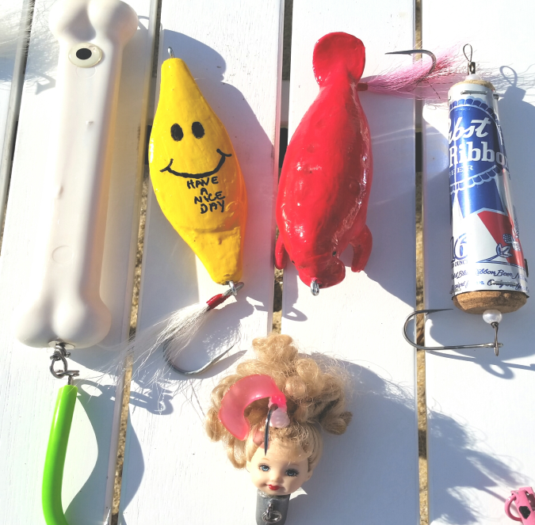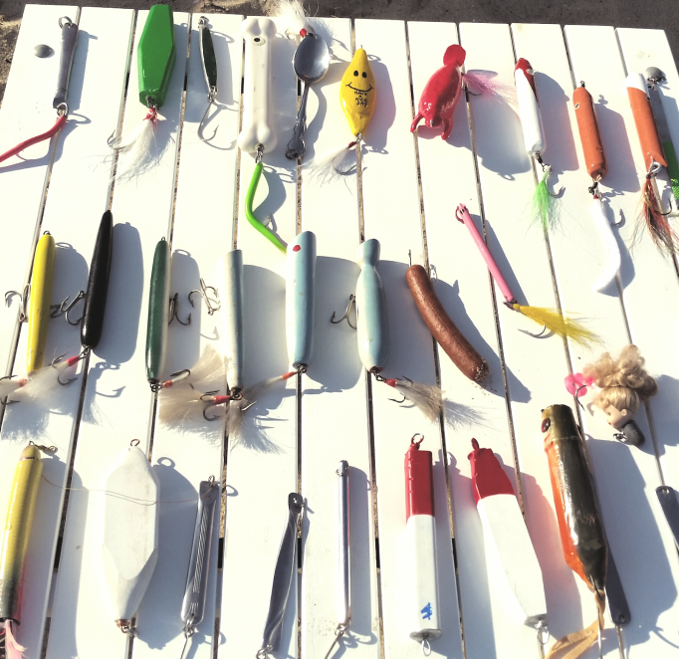

Pin Winners
Pin winners for the month of May were Cosmo Creanga with a 9.92 lb. bluefish and Hawkeye with an 18.36 lb. striped bass. Rounding out the top three in the shore bluefish division were Jim Cornwell who weighed in a 9.90 lb. fish and Ron Domurat with a 9.80 lb. fish. Hawkeye’s fish was the only striped bass weighed in for the month of May.
June pin winners were Hawkeye with a 20.60 lb. striped bass and Jesse Oliver with a 9.80 lb. bluefish. Ron Domurat was the runner up in the striped bass category with a 15.90 lb. fish. Don Scarpone and John Piekos were second and third in the bluefish category 9.50 and 9.25 lb. fish.
At the June meeting, Lou Ferruci won a nice Ron McKee lure in the luck of the draw card raffle of all fish weighed in.
Just a reminder that all 1st, 2nd and 3rd place monthly leaders will be eligible for grand prize drawings at our annual awards luncheon.

Fishing Report
It’s been a stop and go start to the beginning of our year so far. Both striped bass and bluefish were late to arrive to our shores and it seems like it’s been feast or famine ever since. Even after they showed, the bluefishing at Wasque was in fits and starts. When it was hot it was very hot but in between there were times when it was agonizingly slow and uncharacteristic for this time of year. With access to Wasque open once again and a beautiful Rip to fish, many who were out there for the first time in more than eight years thought it was a throwback to the old days while many old salts thought it was not even close. The good news is that Wasque was accessible and many anglers were able to get in on the action during the hot periods as the word quickly spread.
Currently, the shore bluefishing is on the slow side after some hot action under the Poge lighthouse early last week.
Striped bass fishing started slow but was sometimes fair to good at the Wasque Rip and points west. Fish up to fifteen pounds were sometimes mixed in with the bluefish and most bass were taken by anglers slowly bouncing bucktail jigs off the bottom. Currently, OSV access to Wasque is closed both from Norton Point and Chappaquiddick but look for that to change within the next week or so as the Chappy plovers are about ready to fledge. And there are still stripers at the Rip for those willing to make the long walk from the Foster Silva parking lot.
Anglers making the trek to up-island locations appear to be doing well throwing needlefish and eels and Lobsterville has been pretty good the last couple of weeks.
Beach Report
It’s been a tough year for OSV permit holders both on Chappaquiddick and Norton Point. After the breach closed in time to make the trip access to Wasque Point convenient and easily accessible, a nest of piping plovers a mile east of the guard shack currently has it closed to OSV travel and with terns about ready to nest beyond that point, it is unlikely we will see it re-open any time before early August.
On Cape Poge, a pair of plovers decided to build their nest on the front beach out in front of the Dike Bridge which has effectively closed access to East Beach. The good news is that the chicks should be about ready to fledge and the beach should be re-opened within the next week or so.
Further south on East Beach, two pairs of plovers nested in the Lelands Point area. While Wasque Point remained accessible via the back trail on Chappy, one of the chicks recently decided to cross over to the pond side which forced the closure of that trail as well. Look for that chick to fledge around the 5th of July.
OSV travel north of Dike Bridge which included all of Cape Poge was also prohibited as plover chicks that were hatched on the front beach also decided the foraging was better on the Pocha Pond side and crossed over the dunes and trails. Unfortunately, lacking sufficient body weight at the time, some cold rain and fog resulted in their demise so TTOR re-opened the trails just in time for anglers to take advantage of some good bluefishing around the Cape Poge lighthouse. Access to the soft side of the Gut remains closed to OSV travel.
Annual Picnic
The Annual MVSA Summer Picnic will be held at Bend In The Road Beach on Saturday July 11, beginning at 4:00 PM. The usual hot dogs and burgers will served up by President Scarpone but salads and desserts as well as any other gourmet delights members would like to bring will be welcomed and appreciated. As in the past, the club will provide soft drinks and snacks.

Annual Summer Picnic, 4:00 PM, Saturday July 11, 2015, Bend in the Road Beach.
donaldscarpone@yahoo.com, 508-627-1269

August Meeting-Saturday August 8, 2015 5:00-10:00 PM, East Beach. Food, Fishing Contest
donaldscarpone@yahoo.com, 508-627-1269

70th Annual MV Striped Bass & Bluefish Derby, 12:01 AM, Sept. 13, 2015 thru 10:00 PM, October 17, 2015.

