July 2015 MVSA Newsletter
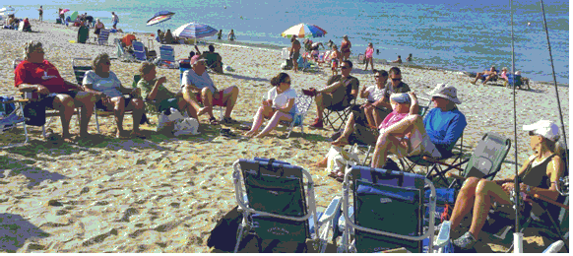
The annual MVSA summer picnic was held at Bend in the Road beach on Saturday July 11. More than 30 members and guests attended and enjoyed the usual good food and good friendship and as is usually the case when a group of fishermen and women gather together, a few fish stories. We also had a special occasion as we helped longtime member Shirley Craig celebrate a milestone birthday.

A special thanks goes to our President Don Scarpone for organizing and doing his usual great job of working the grill. Don was rewarded for his efforts by winning the beautiful Striper Maniac lure in the distance category of the casting contest and a second lure for the luck of the draw for all entries submitted during June in the In-House-Derby. Bob (Hawkeye) Jacobs also won a lure for making the most accurate cast.

In House Derby Pin Winners
Scarpone’s skill and good luck continued in July as he won the monthly pin for catching the largest striped bass a terrific 35.57 lb. fish which was also his career personal best. The “Prez’s” fish also leads the striped bass division of our annual In-House-Derby. July runners-up for striped bass were Jesse Oliver with a 28.60 lb. fish and Hawkeye with a 23.99 lber.
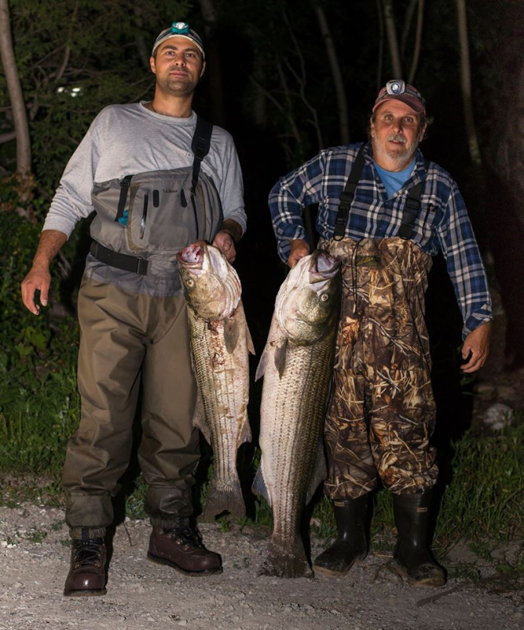
In the bluefish category, new member and former island resident Steve London visiting from Hawaii won the pin with a 9.00 lb. fish followed closely by Ralph Peckham’s 8.86 lb. fish, and Janet Messineo’s 8.56 lber. Cosmo Creanga currently leads the overall In House Derby bluefish division standings with a 9.92 lb. fish.
Just a reminder that any member who enter a fish are eligible for the monthly luck of the draw drawing of Striper Maniac lures.

Fishing Report
After some good fishing the last few weeks of July, a bright full moon paired with some extreme tides, strong southerly winds, weed and a big surf all contributed to a slowdown in the action the last week or so. Prior to all that some good fishing on both striped bass was occurring on both shores as evidenced by Team Woodpeckers photo above. Wasque anglers were also doing well on early evening tides and reliable reports of bluefish up to 14 lbs. were being taken on a regular basis. Up island anglers were n consistently hammering fish to 30 lbs. on a variety of lures and eels. Lobsterville has been hot and cold depending upon the tide but when it’s good, it’s very good with hungry fish hitting needlefish and broken back bombers.
During the lull in striper and bluefishing, some anglers including club members have taken up the slack by fishing for brown sharks along East Beach and the Wasque area. Recently member Matt Malowski doubled up on brown sharks one night and the next night after a 45 minute battle, broke off what was believed to be a large barn door skate.
Beach Report, Chris Kennedy
The 2015 Shorebird Season is shaping up to be an average one for plovers, below average for terns and average for American Oystercatchers. As of August 8, we still have Cape Poge Wildlife Refuge closed to Oversand Vehicles and we have one plover chick which has been traveling from the ocean beach to the bayside at the Narrows for the past two weeks. Once it has fledged (probably another two weeks) we will be able to reopen the rest of the property. Everything else is open from Dike Bridge to Katama.

The Trustees will be working with Harbormaster Charlie Blair to limit the speed of motorboats (ie Jet ski's) from traveling at a high rate of speed up the cove which was formed on Chappy after the closing of the Breach to the beginning of Wasque Point. We're trying to get the jet ski crowd to slow down in that area as we have had several near misses with swimmers trying to swim from the Wasque Swimming beach to the outside beach (Norton Point). Our aim is not to prevent fishermen from landing their boats on the inside of Wasque Point where they then walk over to fish the outside beach.

We are still stationing a ranger at the Gut everyday to prevent boaters from landing in the middle of the tern chick area with dogs, kites and volleyball nets. So far, we have had zero issues with the boaters unlike last year when we would send a ranger out there to deal with issues after they had started.

Just a reminder for the MV Surfcaster's, we often will false chain the entrance to Norton Point to discourage late night partiers and underage drinkers. Nevertheless, the beach is still OPEN for shell fishermen and fishermen. Please feel free to drop the chain, drive through and then put the chain back up around the post!

Lastly, I want to personally thank the Surfcasters for their support and understanding during all of the shorebird closures this summer. I know its not easy to live with, but we are following the law and we are hoping that with the advent of next year's "take" permit, we will be allowed to exercise real flexibility in allowing vehicles to pass through areas where we have a single chick which is preventing access to miles of unrestricted beach frontage. Change is coming but not in time for this season. Will update you all as I learn more developments.

MVSA Scholarship
President Scarpone recently received the following letter from Charles Morano the recipient of the MVSA 2015 scholarship.
“Dear Donald Scarpone and the Martha’s Vineyard Surfcasters Association. I want to extend my sincere thanks for choosing me to be awarded your scholarship. I really appreciated the financial support. I will be attending the College of Charleston in the fall and plan on studying Marine Biology. Thanks again, Charles Morano”.
Agricultural Fair
Once again, the MVSA will place a display in the Martha’s Vineyard Agricultural Fair. This year’s display will be themed ‘Surfcasting-Old and New’ and include tackle and memorabilia from years past as well as modern day equipment. Peter Johnson is in charge of the display and looking for temporary donations to enhance the display. If you have something you think might lend itself to the display, please contact Peter at 703-628-4020 or robertslures@eartlink.com In years past our display has been very well received and won special awards and blue ribbons.
The Ag Fair will be held from August 20 thru August 23.
MVSA Web-Site
Dave Balon reports that our web-site is still very active and people are using it consistently. For the month of July we had 1,655 visits to the site with 4,805 pages viewed. That is about 53 visits to the site per day. Out of those 1,655 visits there were 1,233 unique visits which means, not the same user going to the site over and over.

Jack Yee
Richard Berkley recently informed us that his friend and mentor, Jack Yee passed away. Many knew Jack as the “Mayor” of Montauk and largely credit him with inventing “skishing” and wet suiting. RIP “Mayor!

The Surfcaster
“Even for he who spends months or years, often at night or in foul weather, lashing the water white in quest of a large fish tasting of iodine that has already cost him a great amount of time and money, this sport has an uncanny attraction. The unseen quarry and mysterious dark water, the pleasure taken in the strong and skillful cast, the sound and smell of sea and weather, the healing solitude, and the suspense, are reward enough to the true sportsman who seeks no profit from his hobby, and surfcasting for striped bass probably claims more fanatics than any other form of salt water fishing”. Peter Matthiessen, Men’s Lives.
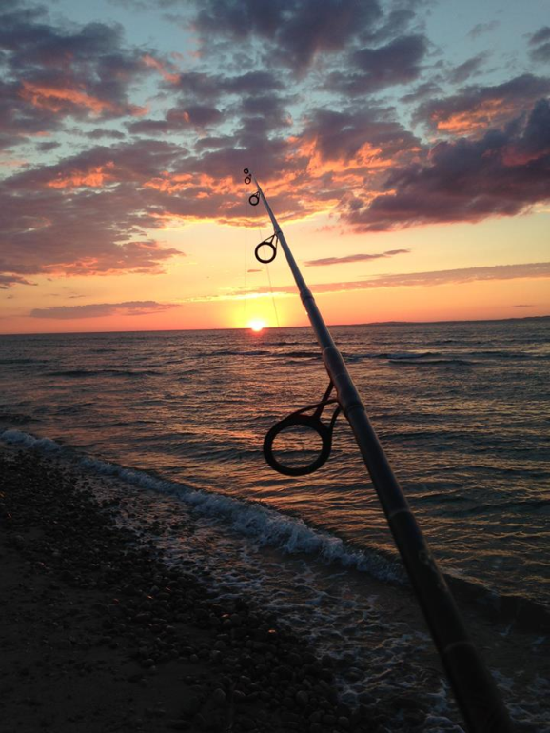 Mark Steponaitis

Calendar
August Meeting-Saturday August 15, 2015 5:30-10:00 PM, East Beach. Food, Fishing Contest
donaldscarpone@yahoo.com, 508-627-1269

70th Annual MV Striped Bass & Bluefish Derby, 12:01 AM, Sept. 13, 2015 thru 10:00 PM, October 17, 2015.
Octoberfish, October 1, 2015, thru October 31, 2015 , Larry’s tackle Shop. 508-627-5088,

u

