MVSA August 2015 Newsletter
Winners Again!!- Once again, the MVSA took home top honors for their display in the annual Martha’s Vineyard Agricultural Fair. With a theme of The Golden Days of Fishing-Can You Remember, the display won a Blue Ribbon as well as the Mrs. Emma May Whiting Special Award which "typifies to an unusual extent the traditional way of life of the Island community". Thanks to Peter Johnson, Paula Sullivan and Jim Cornwell for setting up the winning display. Thanks also to Jesse Oliver, Ralph Peckham, Janet Messineo, Ron Domurat, Paul Schultz, Jim Cornwell, Paula Sullivan and Peter Johnson for their donations of photos and memorabilia and to Peter and Melissa Sliwkowski for the loan of their vintage mount of a 60 lb. Striper.

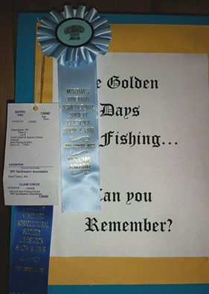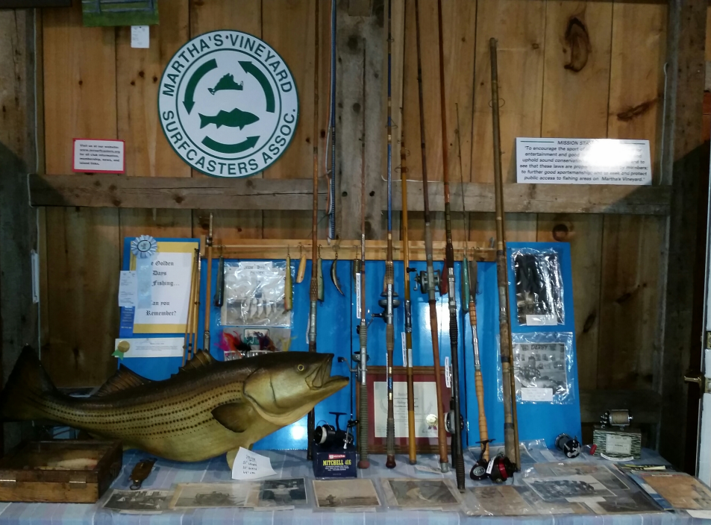

August Picnic and Fishing Contest-Our summer meeting schedule continued on Saturday August 21. The meeting was held on East Beach in front of Dike Bridge. More than twenty members and guest dined on the Prez’s special steamed hot dogs and participated in the fishing contest. As if on que after what had been a slow few weeks, some bluefish fish showed up and Bob and Brenda Beal were the winners of Ron McKee lures for catching the largest and the most fish.

Scarpone also awarded pins for the July In-House Derby winners. In the striped bass category, the “Prez” took the gold for his 35.57 lb. personal best striper followed by Jesse Oliver’s 28.60 lb. fish and Hawkeye’s 23.99 lber. The bluefish winners were new member and former resident Steve London who was visiting from Hawaii, with a 9.00 lb. fish, followed by Ralph Peckham’s 8.86 lber. and Janet Messineo’s 8.56 lb. fish.

Lou Ferrucci won a Ron MCKee lure in the random drawing for all of the fish entries in July.

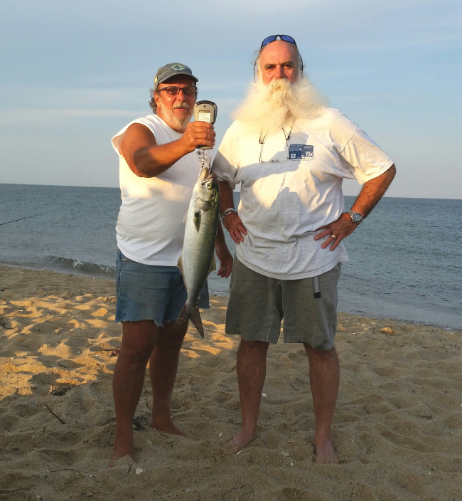
President Scarpone weighs in a bluefish for Bob Beal

In House Derby-The “Prez” Don Scarpone currently leads the striped bass category with his 35.57 lb. fish while Cosmo Creanga leads the bluefish division with a 9.92 lb. fish. Dave Kolb has taken an early lead in the false albacore category with a nice 9.30 lb. fish.

Brown Sharks-Brown Sharks were around in good numbers in August and in addition to providing some fun and excitement, helped fill the void due to the lack of bluefish and striped bass

Ron Domurat and new member Jason Patterson doubled up one night but lost both. A few nights later Jason got one to the beach even before darkness set in. The “Prez” got so excited about the prospects of catching one, he put together an impromptu contest a few nights later that was won by Ralph Peckham’s eight footer. Lines hadn’t been in the water more than five minutes before Jim Fraser hooked and lost one and one of our more well known members who shall remain unidentified, watched a rod and reel disappear before he could get to it.

Until six or seven years ago the MVSA would stage an annual summer brown shark contest but very few were caught so the contest was discontinued among fear that their numbers were dwindling. But in recent years they appear to showing up in greater numbers and providing some great fun for anglers from New Jersey to the Cape and it’s unlikely any surf angler will ever experience the pull of a larger fish while fishing from the beach. Former resident and MA DMF Greg Skomal has provided Don Scarpone with some tags should we ever decide to again make this an annual event.

We are at the northern range of this migratory shark which can grow up to more than eight feet in length. While it can be alarming to some people to see one up close or even hear that they are being caught less than a hundred feet off the beach, brown sharks are relatively harmless bottom dwellers and prefer a meal of small fish, rays, squid or crabs. Most anglers targeting sharks use bottom rigs baited with dead eels, bunker or mackerel chunks, or squid.

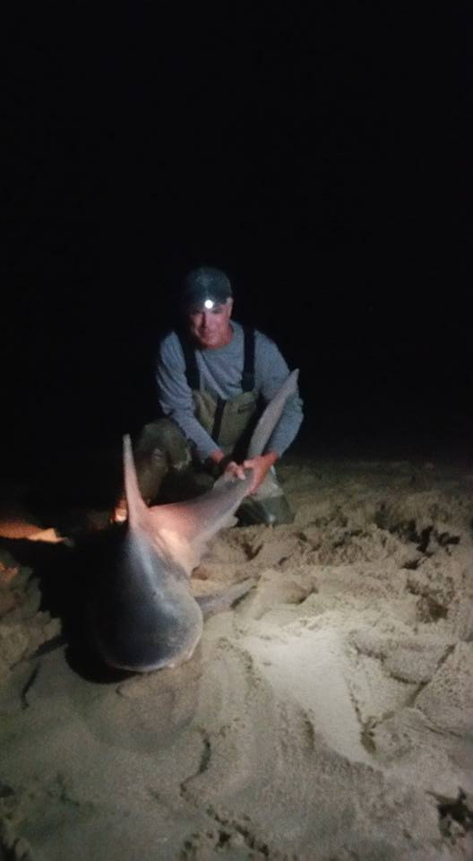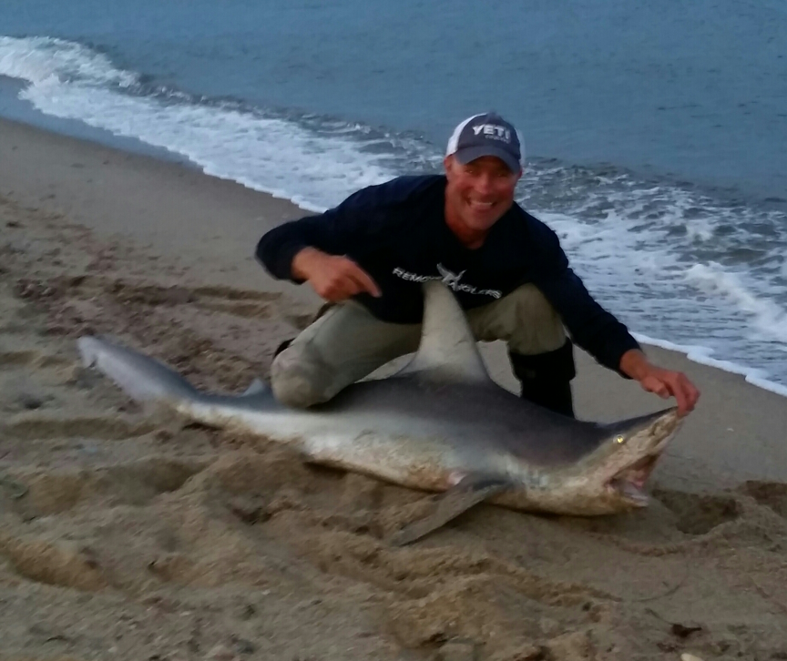
Photo by John O’Connell

Beach Report–by Chris Kennedy

The summer is winding down on The Trustees’ beaches and while we know that we have more beautiful summer weather ahead of us, it’s a good time to assess the past few months and look forward to the next few.

Beach Access and Shorebirds

The Trustees had an average year for Piping plovers, terns and American Oystercatchers. Piping Plover productivity was 1.13 fledged chicks per pair of breeding adults– just under the target goal of 1.24. One of the highlights was the fledging of 12 plover chicks from Norton Point.

Beach access was often impacted during this shorebird season. For instance Cape Poge Wildlife Refuge was closed for vehicle access for more than 30 days this season due to the presence of plover chick’s crossing over the barrier beach south of the Cedars. As well, Norton Point was closed for its “normal” month and a half to protect plover chicks. No surprises at Norton Point for beach managers but the prolonged closure of Cape Poge was not anticipated. For 2016, we are told that relief may be in sight for Cape Poge with the introduction of a new statewide plover management plan. Will pass along any updates as we hear them.

American Oystercatcher productivity 1.15 is perhaps the highest on the Vineyard and certainly well into the positive territory for productivity goals. 15 chicks from 13 pairs

Least Terns had excellent productivity at the Gut (Cape Poge) and zero productivity on Norton Point Beach. The Norton Point nests were predated (several hundred nests) during two nights. Due to rain, we are not entirely sure if it was crows, gulls, skunks—or perhaps all three predators that destroyed the tern nests. Those terns never re-nested.
Common and Roseate terns had zero productivity on Norton Point Beach – predators seem to be the cause.
Black skimmers are still nesting at Norton Point. There are at least 4 pairs, possibly 5. Late nesting in this species is not uncommon.

Looking Forward

The closing of the Norton Point Breach opened up the possibility of allowing OSV access to Chappy for the first time in almost 8 years. The point at which it reconnected at Wasque was thin and tenuous for almost a month before The Trustees was able to open the connection point for regular OSV access. It remained somewhat static for much of the summer but beginning in August the beach began to become thinner with steep sloping oceanside beachfront. Waves hitting the beach hit on the steep angle which exacerbated the slope steepness and continued to pull sand away from the connector.

The late August full moon tides hastened the erosion of the beach and it has been closed for nearly a week as of early September. Will it rebound and become broader? We don’t know. It may continue to erode and break through once again. History of past breaches at Norton Point suggests that sometimes it takes a year or more for the beach to begin accreting or growing. Perhaps we have just experienced a brief period of accretion which will now be followed by a cycle of erosion? There is no question that the current beach at Wasque Point is too dangerous to allow vehicle passage. Again, we will let folks know of the beach status, especially with the fall fishing derby season upon us.
Cape Poge and East Beach, as well as Norton Point are otherwise open as normal. Travel through the Dike Bridge swimming area will be reopened for OSV travel after Labor Day until next April, 2016. Use care traveling to the Cape Poge Gut around high tides as you may find yourself cut off from bayside travel until the tide drops. Please do NOT travel down the outside of the Elbow past the Windmill House. The landowner of that house has been welcoming to all fishermen to pass by the house at any time of the day or night, but he has asked, and The Trustees have agreed to ask all beach travelers to respect his rights to some privacy on the ocean side beach of his property.

At Long Point, the entrance into the Wildlife Refuge will switch over from Waldron’s Bottom to Deep Bottom on September 10. Fishermen may access the winter parking lot to fish Tisbury Great Pond or South Beach 24/7 but beach driving is not allowed. This is a park and walk situation.

Finally, the Brickyard is NOT open for public access at this point and we would ask all to respect the rights of our neighbors on Gosnold’s Way and not drive down to the Brickyard to fish. We are in the process of developing a management plan for the property but it will most likely not provide for parking at the Brickyard.

We have said it before but it’s important to reiterate The Trustees appreciation to all of the Surfcaster’s for their patience and support this past summer. Here’s hoping for fair tides and winds, and a bountiful fall fishing season! Good luck to all.

Fishing Report-As we near the start of the Derby surf jocks become close mouthed and reports become harder and harder to come by. But the big news is the early arrival of huge numbers of false albacore and big concentrations of bait which include peanut bunker which hasn’t been seen in these big numbers in years. Both the outer and inner Edgartown Harbor have been loaded with fish and bait but all the usual albie haunts including Eastville, Tashmoo, Mememsha and Lobsterville are providing great action with pink being the hot color this year.

With the arrival of albies in such huge numbers, reports of bonito have been scarce even from the area of the Hooter which had been loaded with sand-eels and big numbers of fish.

Reports of striped bass have been very scarce the last few weeks. If surf anglers are catching them, they are being very quiet about it.

Bluefish reports are spotty but they occasionally show up in good numbers at the Wasque Rip as well as East Beach.

Good luck in the Derby, with all the bait around it should be a good one. We have some great anglers in our club and as in years past, MVSA members will be right in the thick of the competition.

Just a reminder that a 32” one fish daily limit on striped bass is in effect. Derby entrants may be faced with a difficult decision if the first they catch meets the minimum size requirement. In years past when a one fish limit was in effect, several anglers were suspended due to high-grading. If you catch a fish that meets the minimum size requirement and think it might win a prize, the best advice we can give is to stop fishing to avoid being tempted to high-grade.

MVSA Web-Site-Webmaster Dave Balon reports that our website is still going strong and still getting a lot of usage. For the month of August we had 1,542 visits to the site with 4,442 pages viewed. On average around 37 visits to the site per day. Out of those 1,542 visits there were 1,144 unique or fist time visits. Dave said he totally expects the “contact MVSA” page to get more active as people reach out to us for Derby and fishing info. We will tell them exactly where the fish are at…in the Atlantic!

Calendar

70th Annual MV Striped Bass & Bluefish Derby-, 12:01 AM, Sept. 13, 2015 thru 10:00 PM, October 17, 2015.
Octoberfish, October 1, 2015, thru October 31, 2015- Larry’s tackle Shop. 508-627-5088,

