MVSA April 2015 Newsletter
March Meeting-More than 25 members showed up for the March meeting which was a fun event and included a used tackle sale by members a number of which left later with some great bargains on lures and other tackle. President Scarpone and treasurer Phil Horton also presented a financial update and reported that the club bank balance currently stands at more than $12,000 much of which will be used to make charitable donations or cover expenses like the annual MVSA scholarship, the Rod & Gun Club Kids Trout Derby, and liability insurance.
President Scarpone reviewed the schedule for the balance of the year which includes a ‘mystery’ guest speaker at the May 6th Rod & Gun Club meeting who will talk about catching large striped bass. Summer meetings will be held outdoors. The June and August meetings will be held on East Beach and include grilled hot dogs and/or burgers and the Annual club picnic will be held at Bend in the Road Beach on July 11, 2015.
Ideas are also being solicited for the MVSA exhibit which will be on display at the Annual Agricultural Fair. In years past our display has proven to be immensely popular and won Blue Ribbons as well as Awards of Special Merit. Peter Johnson and Paula Sullivan do a terrific job of setting up the display every year but could always use some help planning and setting up the exhibit. paulasully@yahoo.com, robertslures@earthlink.com
Fishing Report-As of April 20, there have no reports of fish being caught and it appears as though the season is at least two weeks behind schedule. However, there have been reports of herring in the runs and gannets diving on bait along the south shore. In addition, with sunny days rapidly warming the water, can stripers and bluefish be far behind?
Beach Report-In spite of the tough winter we experienced, most of the beaches we travel survived the winter quite nicely. Norton Point is open to OSV travel from the left fork entrance to approximately one quarter mile west of the ‘new’ connection to Wasque and Chappaquiddick.
On Cape Poge, with the exception of the Trustees bathing beach which is closed from in front of Dike Bridge north to the Cedars, all beaches and trails are currently open to OSV travel but vehicle drivers should be cautioned that some areas are ‘tiered’ or ‘cliffed’ pretty badly, particularly the front beach from the access area at the Cedars north to the jetties. The area in front of the Cape Poge lighthouse is in good shape but the ‘Elbow’ lost a good deal of sand and travel on the rocky beach is ‘sketchy’ and uncomfortable at best.
With regard to the new connection at Wasque which finally closed the breach after eight long years, Chris Kennedy sent along the following on 4/16/15. “The high tide over-wash at the connection is slowly filling in some of the "swan pond" so it’s moving in the right direction. I am not worried about the connection breaking through at this point--only concerned about how steep the end of Leland is for inexperienced drivers. ( As of 4/16, the Trustees have wisely closed the new connection to OSV travel)
Kennedy also reports that OSV permits are available at TTOR’S Vineyard Haven office, the County Administration office at the airport, and Coops Bait and Tackle. Permits can also be purchased from TTOR rangers. The Cape Poge/Wasque and Norton Point Beach Oversand Vehicle Permit (OSV) fee structure for 2015 is:
$180 for Cape Poge/Wasque (includes a complimentary Trustees Family-level membership)
$90 Norton Point Beach – Island Vehicle**
$140 Norton Point Beach – Off-Island Vehicle
$250 Combination Permit – Island Vehicle** (Cape Poge/Wasque & Norton Point Beach permits and a complimentary Trustees Family-level membership)
$300 Combination Permit – Off-Island Vehicle (Cape Poge/Wasque & Norton Point Beach permits and a complimentary Trustees Family-level membership)
Aerial View of Wasque and Norton Point as of 4/15/2015
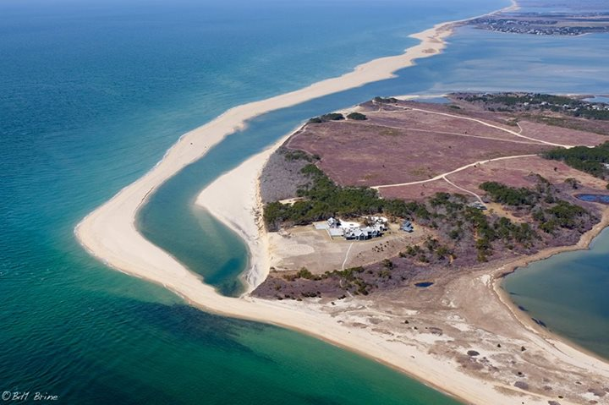
Beach Clean-Up-On April 11, fourteen members from the MVSA participated in the 23rd annual Vineyard Conservation beach clean-up. Members scoured South Beach the Norton Point Breach to beyond the Right Fork parking lot. Also included was the area around the Trustee’s air compressor where much debris was found. In the process members picked up enough trash to fill a town dump truck to overflowing. Participating members were: Paul Schultz, Ron Domurat, Peter Johnson, Ralph Peckham, Lou and Jean Ferruci, Don Scarpone, Jack and Jared Livingston, Dave Kolb, Dave Nash, Robin Bray, Dave Balon and Phil Horton.
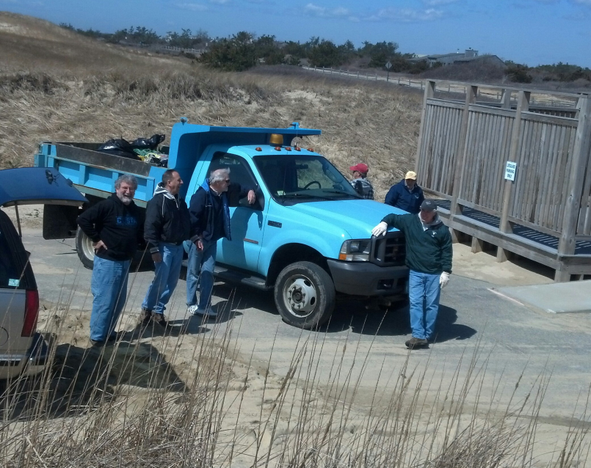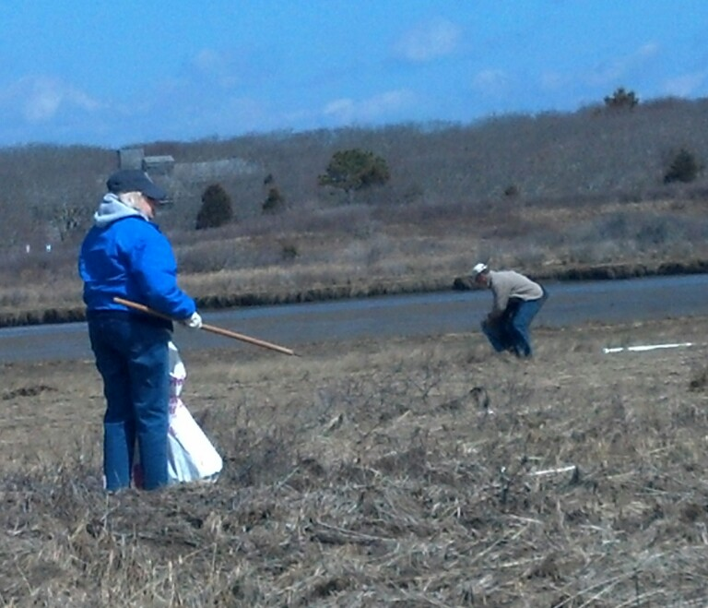
Striped Bass Regulations for 2015-The Division of Marine Fisheries has adopted a 1-fish recreational bag limit for Atlantic striped bass in 2015; the recreational minimum size limit remains the same at 28". This bag limit reduction (from 2 fish) was undertaken to reduce recreational harvest in Massachusetts by at least 25%, as required by the interstate management plan. Massachusetts’ commercial quota has also been reduced by 25%. Read on for further details.
This past October, the Atlantic States Marine Fisheries Commission approved Addendum IV to Amendment 6 to the Interstate Fishery Management Plan (FMP) for Atlantic Striped Bass. The Addendum responds to results of the 2013 benchmark stock assessment, which found that fishing mortality in 2012 was above target, and female spawning stock biomass has been steadily declining below the target level since 2006.
Addendum IV adopts a 25% harvest reduction from 2013 levels for coastal fisheries, and 20.5% harvest reduction from 2012 levels for the Chesapeake Bay fisheries (this lower reduction is due to the Bay jurisdictions taking a 14% cut in 2013 based on their management program). For the coastal fisheries, the Addendum reduces the commercial quotas by 25% and decreases the recreational bag limit to 1 fish. Under Amendment 6, states may implement alternative state-specific recreational measures if they can demonstrate that the measures will have the same conservation value.
Marine Fisheries collected public comment on several options to comply with Addendum IV this past winter. At the request of some representatives and participants in the for-hire fishery, we entertained two alternatives to the 1 fish at 28" FMP standard that included 2 fish at more conservative size limits; these alternatives would have applied only to the for-hire fishing mode.
After careful consideration, Marine Fisheries and the Marine Fisheries Advisory Commission selected the FMP standard of 1 fish at 28" minimum for all modes (private and for-hire). This change has the best chance of achieving a 25% harvest reduction, is easiest to understand, encourages compliance, and simplifies enforcement. In addition, public support for the 2-fish alternatives was limited.
Harvest projections for mode-specific regulations are less certain than for fishery-wide regulations. Confidence in the effectiveness of mode-specific regulations is further reduced if compliance erodes. Introducing a separate striped bass measure to regulate the for-hire mode from all other recreational fishermen (and commercial fishermen) would reduce compliance and complicate enforcement. Enforcement of alternative rules across the entire population of our for-hire permit holders (numbering 900), particularly when for-hire permit holders are fishing without patrons aboard, would have proven troublesome. A universal rule also removes any negative perceptions about benefits from a “dual-standard” allowed to for-hire patrons. Anglers in Massachusetts will operate under the same rules as those in our neighboring states in 2015, as New Hampshire, Rhode Island, and Connecticut have also adopted 1 fish at 28" minimum rules. For more information, refer towww.mass.gov/marinefisheries.

Massachusetts Salt Water Fishing Permits-MA Saltwater Fishing Permits are available and can be purchased from the MA DF web-site www.mass.gov/eea/agencies/dfg/dmf or by phone at 1-866-703-1925. State law requires that all anglers over the age of 16 must purchase a permit. The permit fee is $10 but free to anglers 60 and over (a small processing fee may apply).
MVSA Website-If you’ve never visited the MVSA website, do yourself a favor and take a look as there is a wealth of good information on it. (www.mvsurfcasters.org) In addition to a Blog which is updated regularly, members and visitors to the site can find information about the club itself including upcoming events, the island in general, the latest newsletter, tackle shops, guides, tides, moon phases, weather links and current In House Derby Standings. The ISLAND INFO page is also being constantly updated with a “live” page that pulls Cape Cod and Island news from local newsfeeds. The site also includes an under-used opportunity to participate in an active club forum.
The website, which is administered by Dave Balon, Phil Horton and Victor Kwortnik who update it regularly and promptly respond to e-mail questions from the ‘contact’ link, has proven to be immensely popular among visiting anglers looking for information about fishing on Martha’s Vineyard. If a Google search is done on Martha’s Vineyard Fishing, the MVSA site consistently comes up in the top three and often number one. Dave Balon reports that we have had inquiries from all over New England and as far away a Brazil, Canada and even had a few from Russia. Dave also reported that from 3/14/2015-4/13/2015, the site had more than 950 hits- 750 of which were new visitors to the site, or visitors that returned for a second look within two hours after their first ‘look’.
Make Your Own Lure Contest-In Reading the Water, the late Dr. Robert Post’s classic book about the great Island surfcasters of years past, Roberto Germani told a story about a bunch of guys fishing on the soft side of the Gut and having a contest using makeshift lures. He said they attached screw eyes and treble hooks to a long kitchen spoon as well as two plastic toy boats- one big and one smaller. They also experimented with a plain piece of Chorizo (Portuguese sausage). He described how they drew the bluefish close to the beach with regular poppers and when they got close enough, fired the spoon and boats at them. He said the wooden spoon didn’t show up that well in the water but as one of the boats was being retrieved, a bluefish hit it and sent the plastic head of the driver flying in one direction while the friction engine went flying off a different way. Later they tried the piece of Chorizo. They drove a piece of heavy monofilament thru the sausage link and tied a treble hook on the end. He said the bluefish wouldn’t touch it! The totals for the day were: small boat-five bluefish, big boat- three bluefish, wooden spoon- one and Chorizo- nothing!
President Scarpone and the MVSA is spinning off a variation of that event and on Saturday June 13 2015 will hold a Make Your Own Lure Contest. The event will be held on East Beach beginning at 5:00 PM and members are encouraged to use their imagination and craft their own lures. At the last two meetings, Don showed the members in attendance lures that he’s made from simple kitchen utensils as well as two wooden lures that he hand crafted and painted himself.
Scarpone says anything goes except a modified store bought lure. Members are encouraged to be creative but Chorizo or any other kind of meat is not recommended. Prizes will be awarded to the anglers whose lure(s) catches the biggest and most fish. A special prize will also be awarded for the most original lure.
Island Cup Fishing Challenge-Another reminder about the 2015 Island Cup Fishing The Nantucket Anglers Club which will be held on Nantucket the weekend of June 19-June 21.In addition to our regular MVSA participants, the club is still looking for three women to match-up against the Nantucket women. Questions or sign-ups can be forwarded to Victor Colantonio, v.colantonio@gmail.com,

Smoked Bluefish-With May and some great bluefishing just around the corner, we thought you might enjoy our dearly departed friend Don Mohr’s tried and true recipes for smoked bluefish and smoked bluefish pate.
Fillet bluefish, skin, rinse and dry.
Mix 1 part kosher salt and 3 parts granulated sugar. Using a shallow glass dish (8x12), cover bottom very lightly with mixture from above.
Place fillets in dish and cover with remaining mixture. (Ok to make two layers) Cover and refrigerate overnight.
Next day, prepare smoker.
Soak (2 pieces) of hickory (very important) for one hour.
Light charcoal and place in bottom pan and place soaked hickory on charcoal.
Fill top pan ½ full of water.
Spray Cooking oil over grill and place in smoker.
Rinse fish and dry for at least one hour, place filets in dish and sprinkle with lemon juice. Sprinkle liberally with brown sugar and arrange on the smoker grill.
Smoke for about one hour (varies according to thickness of filets), remove from grill and cool. Wrap in plastic wrap and refrigerate or freeze.
Pate
8 oz. Whipped cream cheese
½ tsp prepared horseradish
1 small finely diced red onion
6-7 oz shredded smoked bluefish
dash worcestershire sauce
1 tsp lemon juice
(Optional) A pinch of cayenne pepper, salt to taste and/or “a little Grey Poupon”. Mix ingredients and serve with crackers

Calendar

May Meeting, 7:00 PM, Tuesday May 5, MV Rod & Gun Club, Pizza.
donaldscarpone@yahoo.com, 508-627-1269

June Meeting, Saturday June 13, 5:00 PM, East Beach. Make Your Own Lure Contest, Picnic
donaldscarpone@yahoo.com, 508-627-1269

Island Cup Fishing Challenge-Nantucket. June 19 –June 21. Victor Colantonio, v.colantonio@gmail.com,

Annual Summer Picnic, 4:00 PM, July 11, 2015, Bend in the Road Beach.
donaldscarpone@yahoo.com, 508-627-1269

August Meeting-Saturday August 8, 2015 5:00-10:00 PM, East Beach. Food, Fishing Contest

70th Annual MV Striped Bass & Bluefish Derby, 12:01 AM, Sept. 13, 2015 thru 10:00 PM, October 17, 2015.

